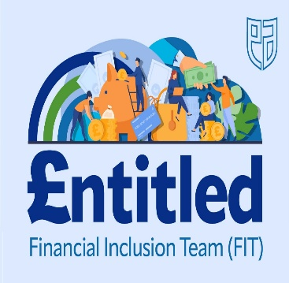
Best Start Grant-School Age Payment

You can claim any time from 1 June 2024 up to 28 February 2025.
Applications open for any children whose date of birth is between 1 March 2019 and 29 February 2020

School Age Payment will be paid automatically for people who claim Scottish Child Payment, with child/children of qualifying age. You can apply whether you are in work or not, as long as you are in receipt of certain benefits. If you do not qualify for Scottish Child Payment but receive Housing Benefit, you can still apply

The school age payment this year is £314.45

It helps with the costs of preparing for school when your child is first old enough to start primary school. You can get the payment for multiple children, as long as each child is the right age when you apply.

To get a payment, your child does not have to take up a place at school. You will still need to apply in the year that your child is first old enough to start school if:
- you're deferring when you child starts school
- your child is not going to school

How to claim:
- phone Social Security Scotland on 0800 182 2222
- claim online at mygov.scot
- download a paper application form from mygov.scot.

For further information see the link below
https://www.mygov.scot/best-start-grant-best-start-foods/how-it-works

