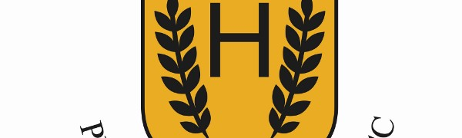
Hurlford Primary School and Early Childhood Centre- Curriculum Rationale
At Hurlford Primary School & Early Childhood Centre, our curriculum is based on Scotland’s curriculum – Curriculum for Excellence (CfE) –which helps our children and young people gain the …
Go to this Sway

