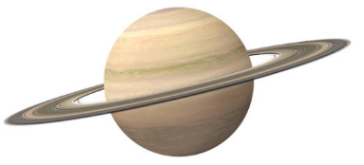**Space Theme Day**

 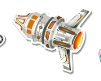

 

               

**27th April 2023**

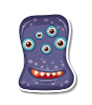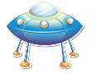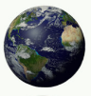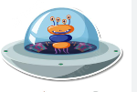

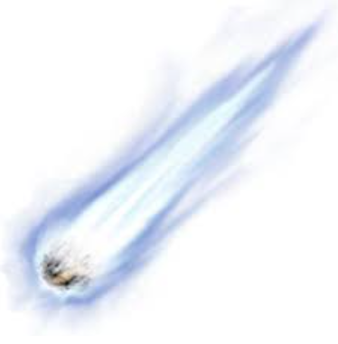



**Saturn sausage sizzlers**

**Moon Walk macaroni**

**Neptune nuggets**

**Space chips & Pluto peas**

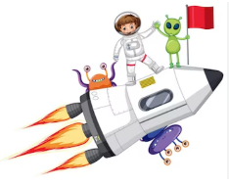**Jupiter jellies / space ship ice lollies**

*Saturn sausage sizzlers = Hot dog Neptune nuggets = vegan nuggets*

*moon walk macaroni = macaroni in a creamy cheese sauce*

*Space chips & Pluto peas = chips & peas*

*Jupiter jellies / space ship ice lollies = jelly / ice lollies*

**Fun fact – on April 12th 1961 Yuri Gagarin was the first ever human being to be in space**

               