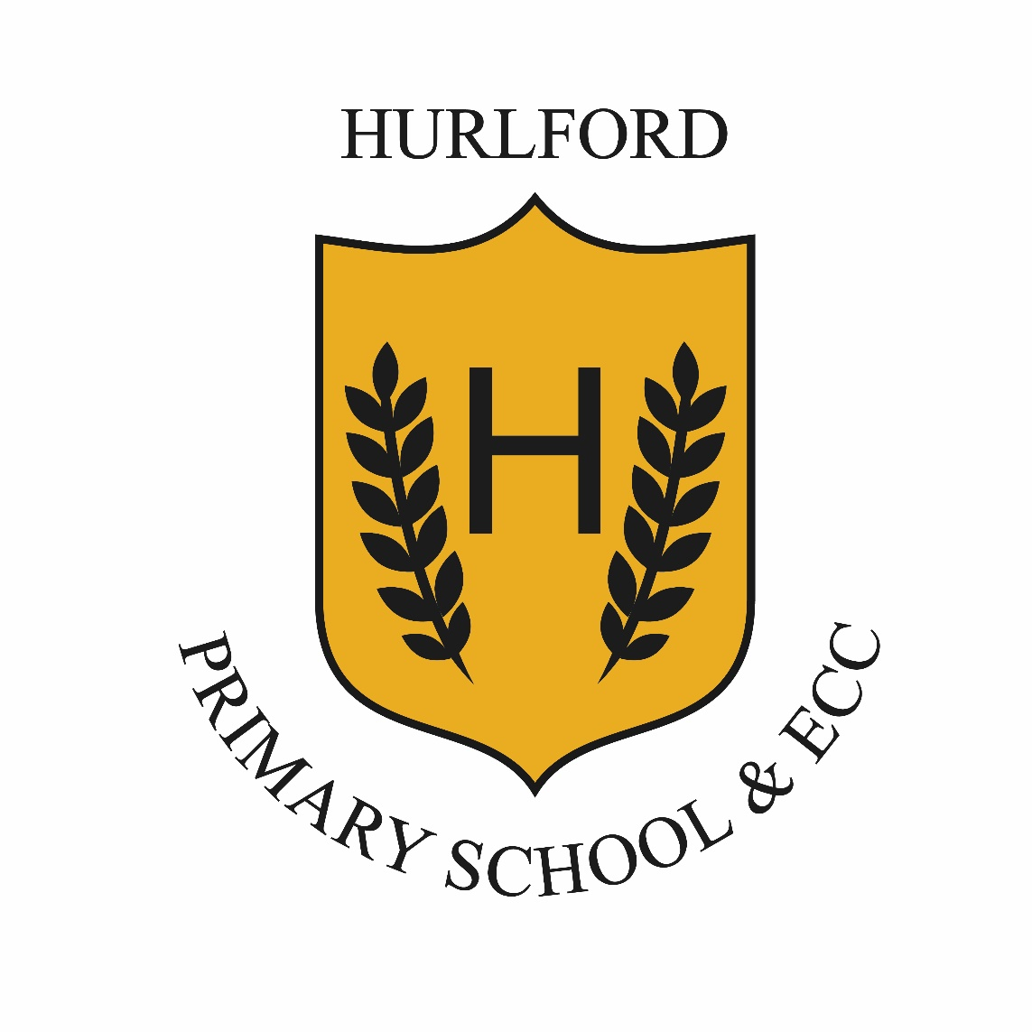
Hurlford Primary School & ECC
Literacy and English Policy

January 2023

Language and literacy skills have a key role in gaining access to all learning and should be developed across all contexts and by every teacher in each curriculum area.
Furthermore, the Literacy and English: principles and practice paper (Education Scotland 2009) outlines the importance of literacy:
Literacy is fundamental to all areas of learning, as it unlocks access to the wider curriculum. Being literate increases opportunities for the individual in all aspects of life, lays the foundations for lifelong learning and work, and contributes strongly to the development of all four capacities of Curriculum for Excellence.

Literacy is fundamental to all areas of learning, as it provides the tools for children to explore all areas of the curriculum. Being literate increases opportunities for children and develops transferable skills for learning, for work and for life.
Improving the quality of children’s learning experiences is central to improving literacy standards and raising attainment therefore, creating the right opportunities for our children to develop these skills is the responsibility of all staff at Hurlford Primary School.
Our Literacy and English Curriculum
At Hurlford Primary School, we follow the EAC Progression Pathways, based on ‘A Curriculum for Excellence’ outcomes and experiences.
We use the benchmarks which are built into the pathways to assess the progression being made. The Progression Pathways embed A Curriculum for Excellence ‘Literacy and English Principles and Practice’ paper:
https://education.gov.scot/Documents/literacy-english-pp.pdf
The pathways have overviews of every level to ensure that teachers are clear of the skills taught prior to the current level as well as being able to see the next steps or extension pathways for every child in the class.
East Ayrshire Literacy Programme
The East Ayrshire Literacy Programme provides a clear framework and guidance for teachers, whilst offering scope for making professional decisions about what and how they teach.

Emphasis is placed on ensuring that Literacy teaching takes place across a broad range of contexts whilst supporting progression in the development of ideas, knowledge, skills and ways of thinking.

The Literacy Programme has been designed to provide:

- A clear structure for the development of all literacy skills and knowledge
- A progressive programme for the teaching of phonics
- Guidance on the teaching of reading (decoding skills, fluency) and the development of comprehension skills (including vocabulary and background knowledge)
- Guidance on the teaching of daily writing and promoting writing across the curriculum
- Guidance on the teaching of spelling and dictation
- Suggestions on how to fit all elements of the literacy programme into your week
- Active learning in literacy linked to play
- Opportunities for children to work collaboratively in pairs/trios/groups.

Reading
At Hurlford Primary School we follow the East Ayrshire Literacy Programme for reading. Our literacy programme is not resource driven, staff are encouraged to use a wide variety of materials to deliver the curriculum. However, we do have core reading schemes which we use. These include:
Primary 1-3: Rising Stars Rocket Phonics, Oxford Reading Tree, Fireflies, Literacy World Satellites and Giglets
Primary 4-7: Literacy World, Novel studies, Giglets
We have a wide selection of class novels which are used to teach reading strategies and are often linked to IDL topics. These novels should be a platform for literacy across learning. We also use read and respond novels across all stages of the school.
A wide variety of support materials from the SAC team are available on EAC SAC Glow tile, for example, SAC DEER (Discovering Enjoyment in Effective Reading).
There are a range of alternative reading resources for children with Additional Support Needs including PM Starters, Songbirds, Rapid Readers, and Literacy World.
Phonics/Spelling
At Hurlford Primary School we follow the East Ayrshire Literacy Programme for phonics and spelling development. There are specific programmes for pupils in P1-3, P4-5 and P6-7. All children should be regularly assessed to ensure they are progressing appropriately.
The recommendation of the Literacy Programme is to teach phonics and spelling to the whole class and then differentiate accordingly.
A wide variety of support materials from the SAC team are available on EAC SAC Glow tile, for example, SAC Octopus (Our clear teaching of phonics underpins spelling).
Where possible, teachers should avoid separating children into too many ability groups as this defeats the purpose of the programme.
Talking and Listening
At Hurlford Primary School, we follow the East Ayrshire Literacy Progression Pathways for talking and listening development.
Regular opportunities are given to children to:
- Provide opportunities for children to participate in discussions through listening and sharing ideas
- Develop skills in listening and talking to others, clarifying their ideas and understanding
- Develop the skills which will allow them to listen attentively, talk clearly and coherently and respond appropriately in different contexts and situations
- Develop the skills, knowledge and understanding to create and develop arguments, opinions and viewpoints linked to a variety of texts and situations.
Writing
At Hurlford Primary School, we follow the East Ayrshire Literacy Progression Pathways for writing development. Writing is a major part of the literacy curriculum and along with reading, talking and listening, makes a significant contribution to the development of children as thinkers and learners.
Class teachers from P1-7 use the whole school strategic overview of writing to plan a balance of all genres over the course of a school session. Staff are encouraged to use a wide variety of topics as stimulus for written work, often linked to IDL topics. A wide variety of support materials from the SAC team, are available on EAC SAC Glow tile, for example, SAC COW (Creating Outstanding Writers) and SAC DUG (Delivering Understandable Grammar) are used to support staff and pupils.
Pupil friendly targets are used for each genre to ensure learners are aware of their success and next steps.
Pupils are encouraged and taught to both peer and self-assess pieces of writing, as well as responding to teacher marked pieces and comments.
Class displays include a variety of support materials for writing, including the language of VCOP (vocabulary, connectives, openers and punctuation). This is used across the school from P2-7 to ensure consistency and understanding of terminology.
Star writers, from each class, are celebrated weekly at Thinking Time and displayed to demonstrate examples of good work and pupil progress.
Talk for writing homework is set prior to the weekly writing task to give pupils the opportunity to talk about what they might write about with an adult – their ideas - in preparation for the writing task

Handwriting
Handwriting is taught as an integral part of all literacy lessons. At Hurlford Primary School we use the East Ayrshire Literacy Programme and Nelson Handwriting scheme to ensure consistency across the school. At Early Level, children are encouraged to develop their emergent writing skills e.g. using and enjoying mark making materials, holding a pencil effectively and forming letters correctly. At First Level, children will be encouraged to give letters and clear shape and orientation, control ascenders/descenders, develop accurate and consistent handwriting and in P4 link their letters. At Second Level, children will be encouraged to use accurate, consistent and neat handwriting and to further develop linked script.
Assessments
Assessments are built into the EA Literacy Programme and allow teachers at these stages to track and monitor the progress being made regularly throughout each session.
Assessments are designed to ensure that the necessary phonemes/spelling strategies have been achieved by each child. Primary 1 begin with a Phonological Awareness Assessment screening tool (Highland Literacy). This is undertaken on three occasions throughout the session (at the beginning of the session, after Christmas and before the end of session in June). All other stages have specific assessments to be used at particular stages of the year. Moderation is used by staff in Writing. The details of these are contained in the FAB folders.
Other Literacy Assessments within the school are listed below:
- ELLAT – ECC and P1 ( November)
- P1 Highland Phonological Awareness – end of December and June
- P3 pupils complete QUEST screening at the start of the new academic session which leads to Diagnostic Assessments, if required
- P3-P7 complete the WRAT spelling tests annually in May. These tests are provided by EAST. If required, particular children then go on to complete the YARC assessment
- P3 – P7 GL Assessment in Reading
- Twice yearly writing baselines (following genre specific calendar)
- Scottish National Standardised Assessments are completed by P1, P4 and P7 pupils. These are diagnostic and are used by the class teacher as an additional assessment tool.
Tracking and Monitoring
Teachers are required to complete the EAC Tracking and Monitoring tool four times every session – September, November, February and May. Progress is discussed with the Senior Management team at regular GIRFEC meetings.
All children are recorded as achieving/working towards a Curriculum for Excellence level (Early –Third) and show how much progress they are making towards the National Expected Level (Early Level by end of P1, First Level by end of P4, Second Level by end of P7).
Class layout and display
All classes should ensure that that their literacy displays contain the agreed common themes of the EAC Literacy Programme. These include common/tricky words, phonemes, reading strategies, writing support materials etc. Classes should have distinct literacy areas, which are clearly labelled, and which allow children to access support resources independently. Dictionaries and thesauruses should always be readily available to children in P3-7. All classes should have a class library area where children are encouraged to access a variety of text types independently.
Teaching and Learning
Effective learning and teaching in literacy will involve a skilful mix of learning and teaching approaches including:
- Planning learning and teaching using the EAC Literacy progression frameworks and the East Ayrshire Literacy Programme
- Providing rich literacy experiences as part of our day-to-day learning and teaching programmes
- Engaging in cross curricular links and real-life situations so giving children opportunities to develop high levels of literacy skills across the curriculum
- Delivering literacy within a learning environment that supports challenge and enjoyment and raises attainment
- Recognising the importance of listening and talking and of effective collaborative working in learning
- Planning high quality assessment which allow learners to apply their learning in new and unfamiliar contexts and to promote higher order thinking skills
- Having a clear picture of the progress of each child across all aspects of literacy.
- Effective direct and interactive teaching
- Active learning and planned purposeful play
- Collaborative working and independent thinking and learning
- Making meaningful links for learners across different curriculum areas so that concepts and skills are developed further by being applied in different, relevant contexts
- Frequent opportunities to communicate in a wide range of enjoyable contexts, for relevant purposes and for real audiences with and beyond places of learning
- Building on the principles of Assessment is for Learning, including understanding the purpose and relevance of the activities
- The appropriate and effective use of ICT

See for EAC Literacy and English Progression Pathways on GLOW SAC tile

