We have had a busy week in maths making arrays and sets to support our work on the concept multiplication.

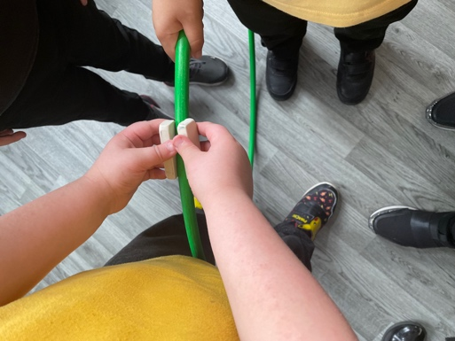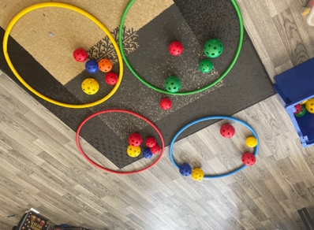

Forces

Making a brake.