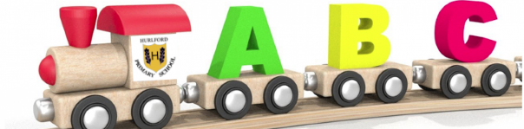Hurlford Early Childhood Centre

Core Muscle Exercises

1. **TIGHTROPE WALKING**: All you need is a bit of masking tape and a little imagination, and you can make all kinds of tightrope obstacle courses using your child’s favourite toys. A simple example is to have her walk from one end of the room to another with an object in each of her hands, and then have her stand on a step stool at the end of the ‘tightrope’ and bend over to place each object into a bucket. Simple, easy, and effective!
2. 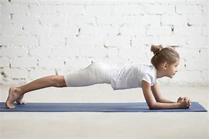**PLANK**: While boring on its own, engaging in a contest to see who can hold a plank the longest can make this core strengthening exercise a little more exciting, and you can step it up even further by having fun wind-up toys walk beneath your child while she holds the plank position.
3. **ANIMAL WALKING**: Write a bunch of different animals on different pieces of paper, throw them into a hat, have your child randomly choose a few, and then have her walk across the living room while pretending to walk like the animal she chose and see how long it takes the rest of the family to figure out what the animal is. Make sure to include bunny rabbit, snake, bear, and crab in your choices and demonstrate the moves ahead of time so she engages her core properly.
4. 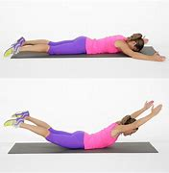**SUPERMAN POSE**: Core exercises for kids have never been easier than with the superman pose. Have your child lie on her tummy and then lift her arms and legs off the ground and see how long she can hold the pose. She can do this on the floor and on an exercise ball, and you can keep her giggling by running race cars over her back!
5. **WHEELBARROW RACES**: If you’re looking for fun core strengthening exercises for kids you can do outside, wheelbarrow races are another classic party game that can help strengthen weak core muscles. Have your child lie face down on the ground, pick up her ankles, and have her ‘walk’ on her hands. Too difficult? Try holding her by the knees instead.
6. **WALL SQUATS**: In addition to strengthening weak core muscles, wall squats (or wall sits) can help strengthen your child’s upper legs. Have your child stand with her back against the wall with her feet a foot or so in front of her, and have her slowly slide down the wall so she is ‘sitting’ without a chair beneath her bum. See how long she can hold the position, and reward her with 2 minutes to play with her favourite toy in between reps!
7. **FUN WITH BLANKETS**: Have your child pull something heavy on a blanket from one end of the room to another. This could be a sibling, a pet, or a bunch of her favourite books. It isn’t easy, but if you cheer her own from the side lines, she may surprise you with her strength!
8. 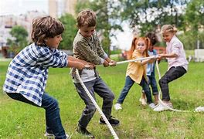**TUG OF WAR**: Ah, I love this game! And you can switch it up in so many different ways, which makes it one of many fabulous core activities for kids. You can use a rope, pillow, or a blanket.