Hurlford Early Childhood Centre
Easter Challenge

1. Build a castle or model from lego or junk modelling. | 2. Draw a picture of your favourite animal. | 3. Play a game – snap, board game etc.  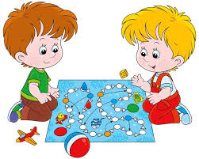 | 4. Enjoy a Disney day – watch all your favourite films.
5. On daily walk count how many rainbows you can see in windows. | 6. Sing and dance – what is your favourite song? | 7. Be creative – paint a picture! Why not have music on in the background….what will you create? | 8. Complete a jigsaw….
9. Have a tea party!….invite some of your toys and even a sibling or a grown up. | 10. Enjoy some yoga with Cosmic Kids.  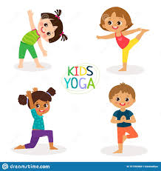 | 11. Give a helping hand!!  What could you help do in the house? Perhaps tidy away toys? | 12. Enjoy some baking!  Why not make some cupcakes or cookies?
13. Do some numeracy – try Education City or Top marks. | 14. Be active  Joe Wicks – The Body Coach TV | 15. Be a Scientist!!!  Watch some amazing science experiments with the Glasgow Science Centre | 16. Make some music  Use pots, pans with spoons. Make some shakers with pasta or rice and a bottle.
17. Sing some Nursery Rhymes. | 18. Some Easter crafts – use old egg cartons, cotton wool or make a sunshine picture. | 19. Be kind!!  Do something kind today. | 20. Make someone smile today.

