

Hillhead Primary School
Date: 9.6.25 | Class: P6/7
Reading
Please read one of your allocated books on Bug Club for 15 minutes each night – this can be with an adult, sibling or independently. If you do not have access to Bug Club then please choose any book/comic that you have.
Follow-up activity:
Write a summary of the story in no more than 50 words.
Spelling  Our spelling this week is focusing on ‘compound words’.  Suggested words to practise:  Butterfly, toothbrush, goldfish, seashell, earring, armchair, cowboy, football, sunflower, babysit  Follow-up activity:  Please separate these compound words and draw a picture of each part. |  | Numeracy/Maths  Sumdog  Word Problems – Please read these questions carefully to see what you need to do in them.  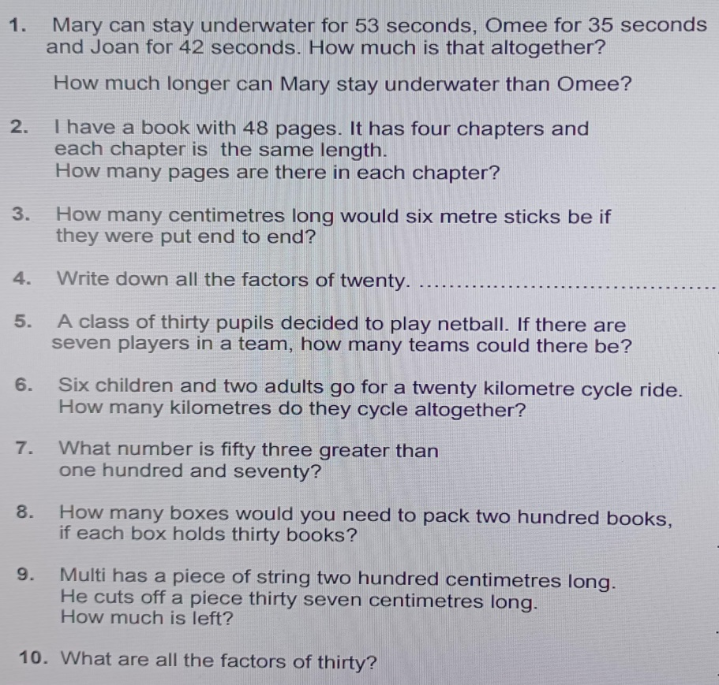
Important Information
- P.E Days – Tuesday
and Thursday
- Water Warriors – Thursday (wear something blue)
- After School – Tuesday (Football: last session)
- Football Festival - Friday

Hillhead Primary School
Date: 9.6.25 | Class: P6/7
Reading
Please read one of your allocated books on Bug Club for 15 minutes each night – this can be with an adult, sibling or independently. If you do not have access to Bug Club then please choose any book/comic that you have.
Follow-up activity:
Write a summary of the story in no more than 50 words.
Spelling  Our spelling this week is focusing on ‘compound words’.  Suggested words to practise:  Butterfly, toothbrush, goldfish, seashell, earring, armchair, cowboy, football, sunflower, babysit  Follow-up activity:  Please separate these compound words and draw a picture of each part. |  | Numeracy/Maths  Sumdog  Word Problems – Please read these questions carefully to see what you need to do in them.
Important Information
- P.E Days – Tuesday
and Thursday
- Water Warriors – Thursday (wear something blue)
- After School – Tuesday (Football: last session)
- Football Festival - Friday

