

Hillhead Primary School
Date: 02.06.25 | Class: P6/7
Reading
Please read one of your allocated books on Bug Club for 15 minutes each night – this can be with an adult, sibling or independently. If you do not have access to Bug Club then please choose any book/comic that you have.
Follow-up activity:
Draw a poster to advertise the book you have read. Make sure you write on the poster why people should read it.
Spelling  Our phoneme this week is ‘ck’.  Suggested words to practise: (c) cupboard  (k) kangaroo  (ck) shipwreck  (ch) toothache  (cc) broccoli  (qu) conquer  (que) technique  (kh) Sikh  (cch) gnocchi  (kk) Hanukkah  Follow-up activity:  Please write all words in a style of your choosing, e.g. graffiti, cut out, rainbow, bubble, pyramid, blue vowel, secret agent. |  | Numeracy/Maths  Sumdog – Probability Challenge  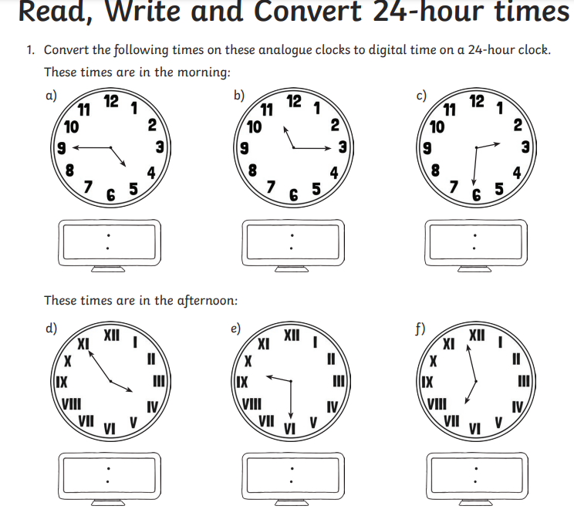
Important Information
- P.E Days – Tuesday and Thursday
- Football – Tuesday
- Sports Day - Friday
*Bump Up day – Tuesday 3rd June*

Hillhead Primary School
Date: 02.06.25 | Class: P6/7
Reading
Please read one of your allocated books on Bug Club for 15 minutes each night – this can be with an adult, sibling or independently. If you do not have access to Bug Club then please choose any book/comic that you have.
Follow-up activity:
Draw a poster to advertise the book you have read. Make sure you write on the poster why people should read it.
Spelling  Our phoneme this week is ‘ck’.  Suggested words to practise: (c) cupboard  (k) kangaroo  (ck) shipwreck  (ch) toothache  (cc) broccoli  (qu) conquer  (que) technique  (kh) Sikh  (cch) gnocchi  (kk) Hanukkah  Follow-up activity:  Please write all words in a style of your choosing, e.g. graffiti, cut out, rainbow, bubble, pyramid, blue vowel, secret agent. |  | Numeracy/Maths  Sumdog – Probability Challenge
Important Information
- P.E Days – Tuesday and Thursday
- Football – Tuesday
- Sports Day - Friday
*Bump Up day – Tuesday 3rd June*

