

Hillhead Primary School
Date: 26.05.25 | Class: P6/7
Reading
Please read one of your allocated books on Bug Club for 15 minutes each night – this can be with an adult, sibling or independently. If you do not have access to Bug Club then please choose any book/comic that you have.
Follow-up activity:
Draw a picture of your favourite part of the story. Colour it in and explain what you’ve drawn.
Spelling  Our phoneme this week is ‘ck’.  Suggested words to practise: (c) clever  (k) kayak  (ck) jacket  (ch) school  (cc) hiccup  (qu) mosquito  (que) cheque  (kh) khaki  (cch) zucchini  (kk) trekking  Follow-up activity:  Please write all words in a style of your choosing, e.g. graffiti, cut out, rainbow, bubble, pyramid, blue vowel, secret agent. |  | Numeracy/Maths  Sumdog – Time Challenge 2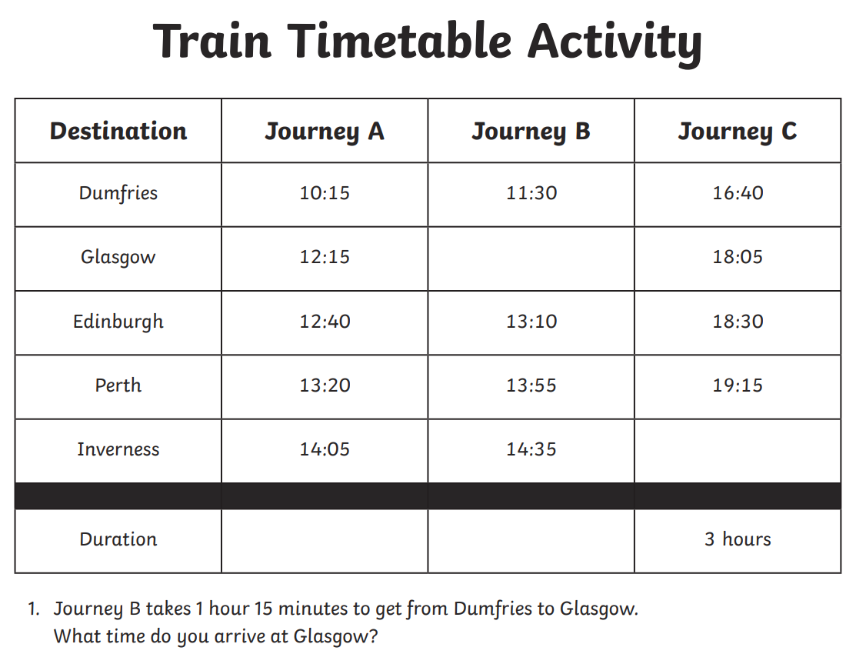  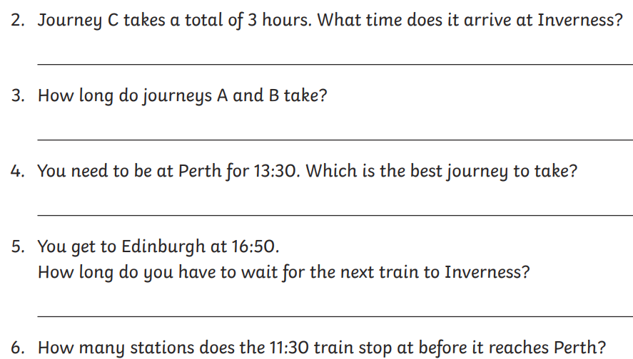
Important Information
- P.E Days – Tuesday and Thursday
- After School Clubs – Games Workshop Monday (last session)
- Football Team Training Tuesday

Hillhead Primary School
Date: 26.05.25 | Class: P6/7
Reading
Please read one of your allocated books on Bug Club for 15 minutes each night – this can be with an adult, sibling or independently. If you do not have access to Bug Club then please choose any book/comic that you have.
Follow-up activity:
Draw a picture of your favourite part of the story. Colour it in and explain what you’ve drawn.
Spelling  Our phoneme this week is ‘ck’.  Suggested words to practise: (c) clever  (k) kayak  (ck) jacket  (ch) school  (cc) hiccup  (qu) mosquito  (que) cheque  (kh) khaki  (cch) zucchini  (kk) trekking  Follow-up activity:  Please write all words in a style of your choosing, e.g. graffiti, cut out, rainbow, bubble, pyramid, blue vowel, secret agent. |  | Numeracy/Maths  Sumdog – Time Challenge 2
Important Information
- P.E Days – Tuesday and Thursday
- After School Clubs – Games Workshop Monday (last session)
- Football Team Training Tuesday

