

Hillhead Primary School
Date: 19.05.25 | Class: P6/7
Reading
Please read one of your allocated books on Bug Club for 15 minutes each night – this can be with an adult, sibling or independently. If you do not have access to Bug Club then please choose any book/comic that you have.
Follow-up activity:
Draw a picture of your favourite part of the story. Colour it in and explain what you’ve drawn.
Spelling
Our phoneme this week is ‘oy’.
Suggested words to practise:
(oi)coin, poison, asteroid, (oy)enjoy, royalty, convoy.
Follow-up activity:
Please write all words in a style of your choosing, e.g. graffiti, cut out, rainbow, bubble, pyramid, blue vowel, secret agent.
Numeracy/Maths
Sumdog – Time Challenge
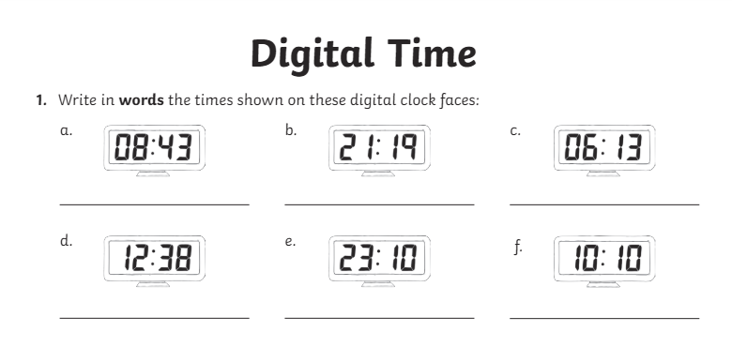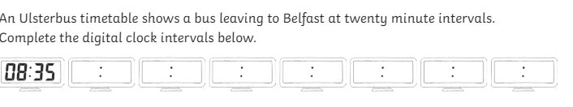
Important Information
- P.E Days – Tuesday and Thursday
- P7 Science Event @ Grange – Wednesday
- Marvellous May Fun Day – Saturday 24th May (11am-3pm)
*Walk to School Week*

Hillhead Primary School
Date: 19.05.25 | Class: P6/7
Reading
Please read one of your allocated books on Bug Club for 15 minutes each night – this can be with an adult, sibling or independently. If you do not have access to Bug Club then please choose any book/comic that you have.
Follow-up activity:
Draw a picture of your favourite part of the story. Colour it in and explain what you’ve drawn.
Spelling
Our phoneme this week is ‘oy’.
Suggested words to practise:
(oi)coin, poison, asteroid, (oy)enjoy, royalty, convoy.
Follow-up activity:
Please write all words in a style of your choosing, e.g. graffiti, cut out, rainbow, bubble, pyramid, blue vowel, secret agent.
Numeracy/Maths
Sumdog – Time Challenge
Important Information
- P.E Days – Tuesday and Thursday
- P7 Science Event @ Grange – Wednesday
- Marvellous May Fun Day – Saturday 24th May (11am-3pm)
*Walk to School Week*

