Owls, Hedgehogs, Rabbits

7.1.24

Spelling Words

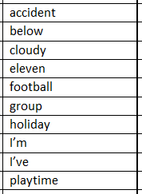Please complete 2 spelling activities

Owls, Hedgehogs, Rabbits

7.1.24

Spelling Words

Please complete 2 spelling activities