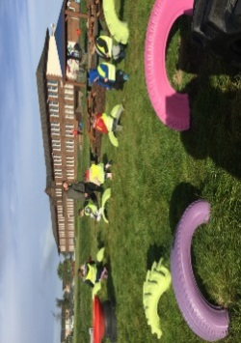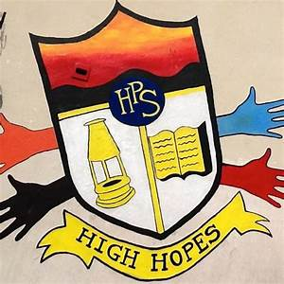

**Literacy**

* Please read this book and answer the questions with a grown up at home. Be ready to talk about your book with the class at the end of the week.
* Continue to write your name in your jotter.
* Complete the ‘th’ activity sheet.

**Things to Remember**

* Names should be clearly labelled on all personal belongings to that they can easily be returned if lost/misplaced.
* Can all Primary 2s line up in house colours with all Primary 2s and 3s at the start of the day, playtime and lunch.

Gym days are

Wednesday & Thursday

**P1/2 Homework**

**w.b: Monday 24th September 2024**

**Other Curricular Areas**

-We have been exploring fairy tales as our class topic. Can you draw a picture of your favourite fairy tale character.



**Numeracy**

* Please complete the counting quantities worksheet.
* 

**P1 Homework**

**w.b.Monday 4th September**

**Additional Information**

* Please return all homework and books on Friday in order for your pack to be given out again on Monday.
* Autumn fun day is this Thursday (19st September) our time slot will be announced soon.