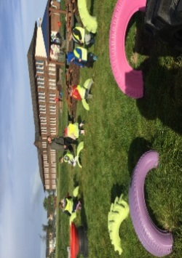

**Literacy**

* Please read this book and answer the questions with a grown up at home. Be ready to talk about your book with the class at the end of the week.
* Continue to write your name in your jotter.
* Complete the ‘qu’ activity sheet.

**Things to Remember**

* Names should be clearly labelled on all personal belongings to that they can easily be returned if lost/misplaced.
* Bring a bottle of water to school every day. We can easily refill it if it runs out.

Gym days are

Wednesday & Thursday

**P1/2 Homework**

**w.b: Monday 16th September 2024**

**Other Curricular Areas**

-We have been exploring day and night can you draw things you would see during the day and what you would see at night. .



**Numeracy**

* Please complete the counting quantities worksheet.
* 

**P1 Homework**

**w.b.Monday 4th September**

**Additional Information**

* Please return all homework and books on Friday in order for your pack to be given out again on Monday.
* Autumn fun day is this Thursday (19st September) our time slot will be announced soon.