Hillhead Primary School

Date: 3.6.24 | Class: P6/7
Reading
Please read for 15 minutes each night – this can be with an adult, sibling or independently. Active Learn (Bug Club logins have been handed out). Remember to do the quizzes at the end of each book. Any issues with log ins, please see me.
Spelling – remember to think about the spelling strategies used for each word. All the words use the ‘kw’ sound in some way.  Suggested words to practise:  SPICY staircase assume assortment sequence silence resuscitate isosceles jostling license rehearse audience psychopath reminisce MILD Sunday Saturday princess fossil Christmas fasten wrestle whistle sword answer rinse tense sickness sadness  Suggested activity:  Must Do Task: rainbow writing  Choose 1 additional spelling task. | Numeracy/Maths  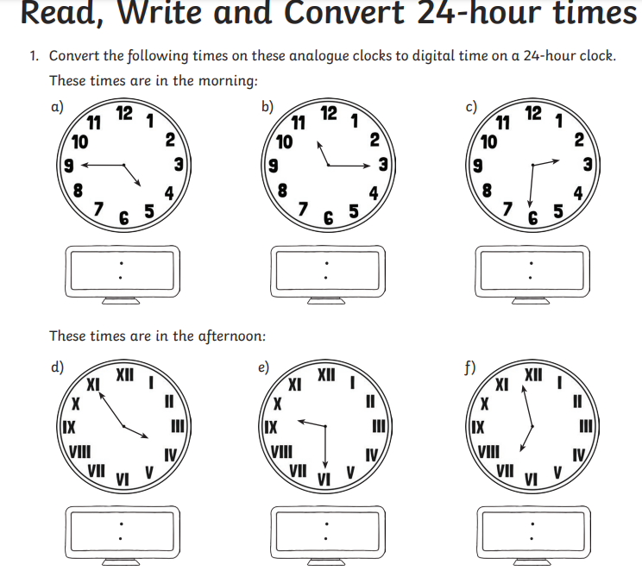  Multiplication – Keep practising the times table you are currently working on.
Important Information
- P.E Days – Wednesday and Friday
remember to bring gym clothes and do not wear jewellery.
- Homework should be handed in to the tray in class by Friday at the latest.
- P7s Only – Science visit at the Grange
- Class visit on Wednesday from Speakers Trust, developing speaking and listening skills. Topic – nature and trees.

