Hillhead Primary School
Date: 29.4.24 | Class: P6
Reading
Please read one of your allocated books on Bug Club for 15 minutes each night – this can be with an adult, sibling or independently. If you do not have access to Bug Club then please choose any book/comic that you have.
Follow-up activity:
Write a summary of the story in no more than 50 words.
Spelling  Our phoneme this week is ‘g’.  Suggested words to practise:  (g)dingo, (gg)haggis, (gu)guard, (gh)yoghurt, (x)example, (gue)fatigue.  Follow-up activity:  Please write all words and draw a picture to match.  Common words for this week are: previous, allow, our, asked, state.  Follow-up activity:  Please write all words in a style of your choosing, e.g. graffiti, cut out, rainbow, bubble, pyramid, blue vowel, secret agent. |  | Numeracy/Maths  Sumdog – Measure Challenge 2  Word Problems – Please read these questions carefully to see what you need to do in them.  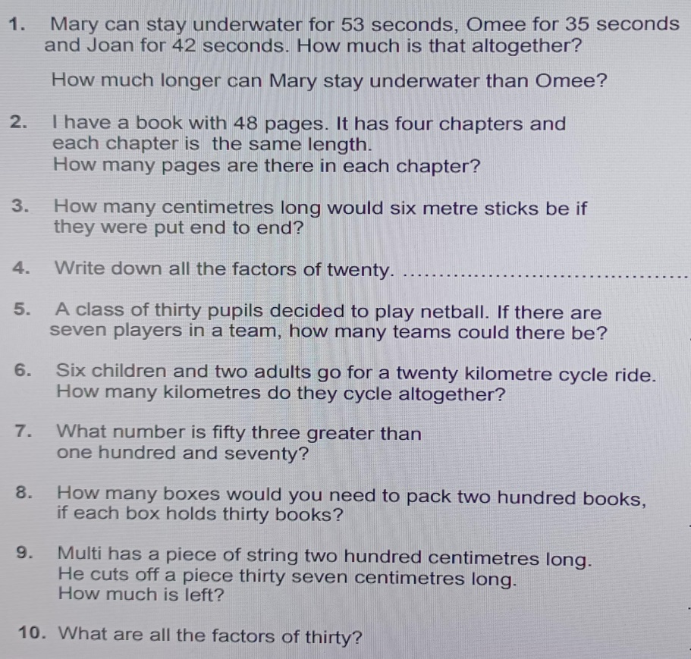
Important Information
- P.E Days – Tuesday, Wednesday
and Thursday
- After School Clubs:
- Girl’s Football (Tuesday)
- Football (Thursday)

*School Closed - Monday 6th May*

Hillhead Primary School
Date: 29.4.24 | Class: P6
Reading
Please read one of your allocated books on Bug Club for 15 minutes each night – this can be with an adult, sibling or independently. If you do not have access to Bug Club then please choose any book/comic that you have.
Follow-up activity:
Write a summary of the story in no more than 50 words.
Spelling  Our phoneme this week is ‘g’.  Suggested words to practise:  (g)dingo, (gg)haggis, (gu)guard, (gh)yoghurt, (x)example, (gue)fatigue.  Follow-up activity:  Please write all words and draw a picture to match.  Common words for this week are: previous, allow, our, asked, state.  Follow-up activity:  Please write all words in a style of your choosing, e.g. graffiti, cut out, rainbow, bubble, pyramid, blue vowel, secret agent. |  | Numeracy/Maths  Sumdog – Measure Challenge 2  Word Problems – Please read these questions carefully to see what you need to do in them.
Important Information
- P.E Days – Tuesday, Wednesday
and Thursday
- After School Clubs:
- Girl’s Football (Tuesday)
- Football (Thursday)

*School Closed - Monday 6th May*

