Hillhead Primary School
Date: 22.4.24 | Class: P6
Reading
Please read one of your allocated books on Bug Club for 15 minutes each night – this can be with an adult, sibling or independently. If you do not have access to Bug Club then please choose any book/comic that you have.
Follow-up activity:
Find any 10 words in your book. Now put them into alphabetical order.
Spelling  Our phoneme this week is ‘f’.  Suggested words to practise:  (f)frightened, (ff)daffodil, (ph)sphinx, (ft)soften, (gh)cough, (ffe) gaffe, (pph) sapphirewing.  Follow-up activity:  Please write all words and draw a picture to match.  Common words for this week are: shoulder, they, called, round, continue.  Follow-up activity:  Please write all words in a style of your choosing, e.g. graffiti, cut out, rainbow, bubble, pyramid, blue vowel, secret agent. |  | Numeracy/Maths  Sumdog – Measure Challenge 2  Word Problems – Please read these questions carefully to see what you need to do in them.  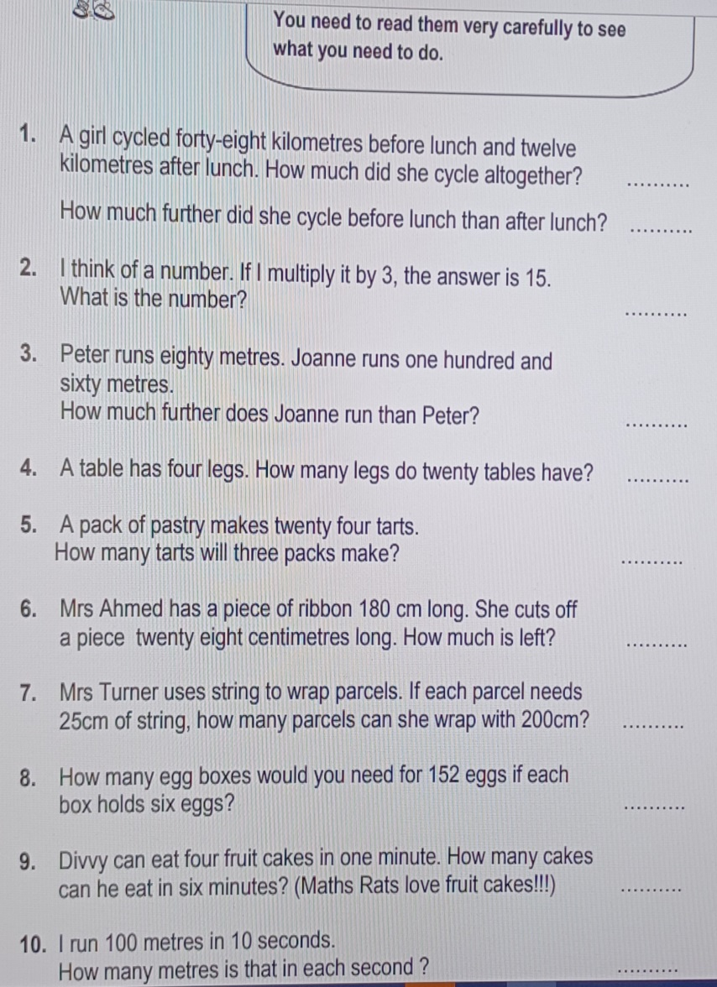
Important Information
- P.E Days – Tuesday and Thursday
- After School Clubs:
- Girl’s Football (Tuesday)
- Dance (Wednesday)
- Progress Evening – Thursday

Hillhead Primary School
Date: 22.4.24 | Class: P6
Reading
Please read one of your allocated books on Bug Club for 15 minutes each night – this can be with an adult, sibling or independently. If you do not have access to Bug Club then please choose any book/comic that you have.
Follow-up activity:
Find any 10 words in your book. Now put them into alphabetical order.
Spelling  Our phoneme this week is ‘f’.  Suggested words to practise:  (f)frightened, (ff)daffodil, (ph)sphinx, (ft)soften, (gh)cough, (ffe) gaffe, (pph) sapphirewing.  Follow-up activity:  Please write all words and draw a picture to match.  Common words for this week are: shoulder, they, called, round, continue.  Follow-up activity:  Please write all words in a style of your choosing, e.g. graffiti, cut out, rainbow, bubble, pyramid, blue vowel, secret agent. |  | Numeracy/Maths  Sumdog – Measure Challenge 2  Word Problems – Please read these questions carefully to see what you need to do in them.
Important Information
- P.E Days – Tuesday and Thursday
- After School Clubs:
- Girl’s Football (Tuesday)
- Dance (Wednesday)
- Progress Evening – Thursday

