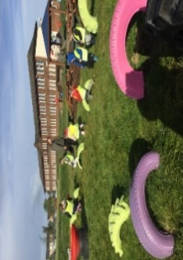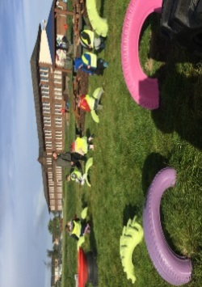

Numeracy

Please complete the numeracy activity sheet in your homework pack.

page1image3332608

**P1 Homework**

**w.b: Monday 29nd January 2024**

**Other Curricular Areas**



We will be looking in the school garden for signs of spring. Try to go on a ‘spring walk’ this week to identify some signs that the new season is on its way. This could be snowdrops or crocuses beginning to bloom, the sun staying out longer in the evening etc. Please draw a picture or email me a photo of what you find.

**Literacy**

* Please read your reading book at home and bring it into school with you every day to practice in class.
* Revise all sounds s, a, t, p, i, n, r m,d,e,c, k, g, l, f, o, b, u, h, w, j, v, y, z, q and x
* complete activity ‘ch’ activity sheet
* Please practise ‘not’ on your common word sheet and revise ’a’ ‘at’, ‘the’ ‘I’, ‘in’, ‘it’, ‘an, ‘is’, ‘and’, ‘am’, ‘me’, ‘my’, ‘did’, ‘as’, ‘he’,’can’, ‘we’, ‘into’, ‘go’, ‘got’, ‘get’, ‘if’, ‘be’ ‘but’ ‘on’, ‘you’ ‘was’, ‘went’ and ‘his’, ‘have’, ‘just’, ‘dad’, ‘are’.

**Additional Information**

-Please keep homework folders in your bag every day as these are often used to practise sounds and common words.

*please practise your sounds and common words at home every day. It really helps you to learn these.

Gym days are

Tuesday and Thursday this week.

**Things to Remember**

* Names should be clearly labelled on all personal belongings to that they can easily be returned if lost/misplaced.
* Bring a bottle of water to school every day. We can easily refill it if it runs out.

**P1 Homework**

**w.b.Monday 4th September**