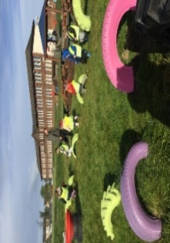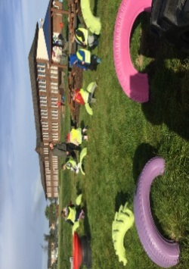

Numeracy

Please complete the numeracy activity sheet in your homework pack.

page1image3332608

**P1 Homework**

**w.b: Monday 5th February 2024**

**Other Curricular Areas**

Our new topic is going to be ‘Castles’ can you draw or make a castle at home using some things you have at home.

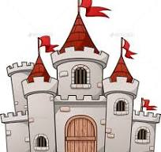

**Literacy**

* Please read your reading book at home and bring it into school with you every day to practice in class.
* Revise all sounds s, a, t, p, i, n, r m,d,e,c, k, g, l, f, o, b, u, h, w, j, v, y, z, q and x
* Complete ‘sh’ activity sheets.
* Please practise ‘by’ and ‘only’ on your common word sheet and revise ’a’ ‘at’, ‘the’ ‘I’, ‘in’, ‘it’, ‘an, ‘is’, ‘and’, ‘am’, ‘me’, ‘my’, ‘did’, ‘as’, ‘he’,’can’, ‘we’, ‘into’, ‘go’, ‘got’, ‘get’, ‘if’, ‘be’ ‘but’ ‘on’, ‘you’ ‘was’, ‘went’ and ‘his’, ‘have’ and ‘just’, ‘to’, ‘your’.

**Additional Information**

-Please keep homework folders in your bag every day as these are often used to practise sounds and common words.

*please practise your sounds and common words at home every day. It really helps you to learn these.

Gym days are

Tuesday and Thursday this week.

**Things to Remember**

* Names should be clearly labelled on all personal belongings to that they can easily be returned if lost/misplaced.
* Bring a bottle of water to school every day. We can easily refill it if it runs out.

**P1 Homework**

**w.b.Monday 4th September**