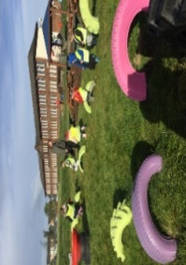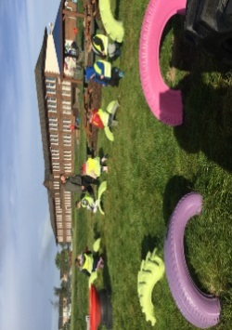

Numeracy

Please complete the numeracy activity sheet in your homework pack.

page1image3332608

**P1 Homework**

**w.b: Monday 22nd January 2024**

**Other Curricular Areas**

**The wee rid motor**

We will be performing the poem ‘The wee rid motor’ at the Scottish Assembly this year. You will find a copy of this in your homework pack. Please practise at home this week.

**Literacy**

* Please read your reading book at home and bring it into school with you every day to practice in class.
* Revise all sounds s, a, t, p, i, n, r m,d,e,c, k, g, l, f, o, b, u, h, w, j, v, y, z.
* Learn sounds ‘q’ and ‘x’ and complete activity sheets.
* Please practise ‘have’ and ‘just’ on your common word sheet and revise ’a’ ‘at’, ‘the’ ‘I’, ‘in’, ‘it’, ‘an, ‘is’, ‘and’, ‘am’, ‘me’, ‘my’, ‘did’, ‘as’, ‘he’,’can’, ‘we’, ‘into’, ‘go’, ‘got’, ‘get’, ‘if’, ‘be’ ‘but’ ‘on’, ‘you’ ‘was’, ‘went’ and ‘his’

**Additional Information**

-Please keep homework folders in your bag every day as these are often used to practise sounds and common words.

*please practise your sounds and common words at home every day. It really helps you to learn these.

Gym days are

Tuesday and Thursday this week.

**Things to Remember**

* Names should be clearly labelled on all personal belongings to that they can easily be returned if lost/misplaced.
* Bring a bottle of water to school every day. We can easily refill it if it runs out.

**P1 Homework**

**w.b.Monday 4th September**