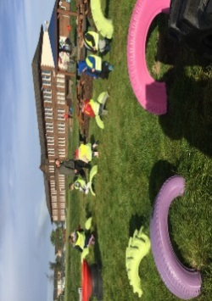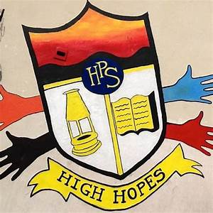

**Other Curricular Areas**

*No Power Hour*

The Eco Committee would like us to look at ways we can save water this month. Please watch the video by following the link below and then design a poster displaying at least one way we can save water. Completed posters will be passed onto Miss Bannister and the Eco Committee and you will be awarded TEN dojos!



[Water Saving Tips and Tricks - Let's Save the Planet - The Environment for Kids (youtube.com)](https://www.youtube.com/watch?v=nTcFXJT0Fsc)

**Things to Remember**

* Names should be clearly labelled on all personal belongings to that they can easily be returned if lost/misplaced.
* Bring a bottle of water to school every day. We can easily refill it if it runs out.

**Literacy**

* Please read your reading book at home and bring it into school with you every day to practice in class.
* Revise all sounds s, a, t, p, i, n, r m,d,e,c, k, g, l, f, o, b, u, h and w and complete activity sheet.
* Learn sounds ‘j’ and ‘v’ and complete activity sheets.
* Please practise ‘for’ and ‘on’ on your common word sheet and revise ’a’ ‘at’, ‘the’ ‘I’, ‘in’, ‘it’, ‘an, ‘is’, ‘and’, ‘am’, ‘me’, ‘my’, ‘did’, ‘as’, ‘he’,’can’, ‘we’, ‘into’, ‘go’, ‘got’, ‘get’, ‘if’, ‘be’ ‘but’ ‘on’ and ‘for’. Please learn ‘you’ and ‘was’.

Gym days are

Wednesday and Thursday this week.

**P1 Homework**

**w.b: Monday 8th January 2024**

**Additional Information**

-Please keep homework folders in your bag every day as these are often used to practise sounds and common words.

*please practise your sounds and common words at home every day. It really helps you to learn these.

Numeracy

Please complete the numeracy activity sheet in your homework pack.

page1image3332608

**P1 Homework**

**w.b.Monday 4th September**