Hillhead Primary School
Date: 04.12.23 | Class: P6/7
Reading

BugClub continues to be a priority so each child needs to be working through a book a week at the least as well as reading a book of their own choosing. Please practice and listen to the assembly lines if your child has a speaking part, thank you. -

We are also allowing children to access books from the school library which they can now take home to read if preferred.
Spelling  Our phoneme this week is ‘oa’ sound, as in approach.  Throat broach coax loathe opened lonely bungalow swallow meadow ownership volcanoes tornadoes oboe heroes emotion piano November brooch poultry smouldering gateau bureau although doughnut  Write a paragraph using these key words OR pick ten and explain what the words mean – choose words you are unsure of.  Sumdog Spelling Challenge | 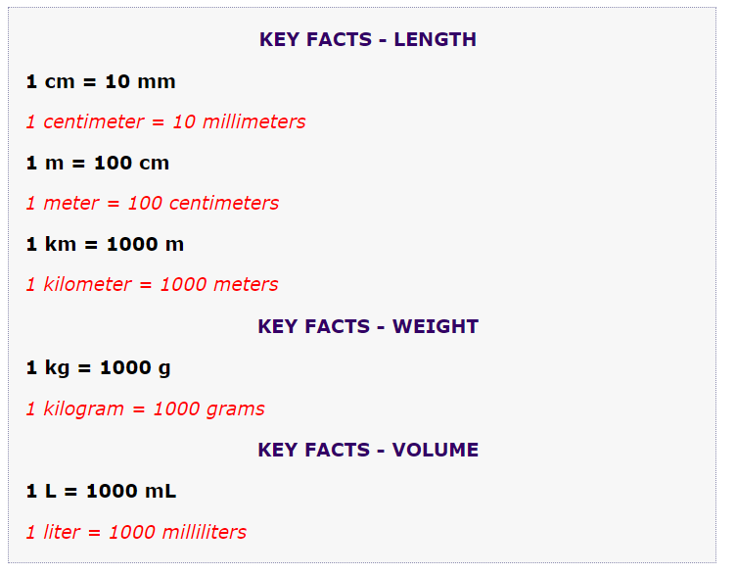  Numeracy/Maths  Convert from cm to mm  - 5.5cm c) 6.7cm  - 12.5cm d) 34.4cm  Convert to metres:  e) 75cm g) 345cm  f) 788 cm h) 999cm  Convert to km:  - 7738m j) 1234m  k) 456m l) 82738m

