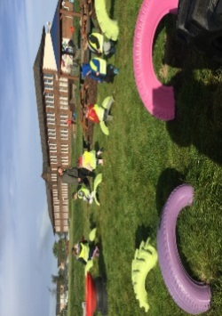

Gym days are

Tuesday and Thursday this week.

**P1 Homework**

**w.b: Monday 13th November 2023**

**Additional Information**

- Thank you to all who came to the first pupil progress meeting of the year.

-Please keep homework folders in your bag every day as these are often used to practise sounds and common words.

*please practise your sounds and common words at home every day. It really helps you to learn these.

**Literacy**

* We will be handing out book bug books to read at home this week with online log ins to be handed out later. Please practise our sound ‘g’ and ‘l’ this week and revise s, a, t, p, I, n, r m,d,e. Complete the ‘g’ and ‘L’ activity sheet.
* Please practise ‘we’ and ‘into’ on your common word sheet and revise ’a’ ‘at’, ‘the’ ‘I’, ‘in’, ‘it’, ‘an, ‘is’, ‘and’, ‘am’, ‘me’, ‘my’, ‘did’, ‘as’, ‘he’ and can.

**Things to Remember**

* Names should be clearly labelled on all personal belongings to that they can easily be returned if lost/misplaced.
* Bring a bottle of water to school every day. We can easily refill it if it runs out.

**Other Curricular Areas**

As the weather is starting to get colder. Can you practice to put on your jacket and zip it up yourself so we are fully prepared for going outside at snack and lunch time.



**Numeracy**

We have been looking at finding numbers before and after to 20. Can you complete the counting sheet provided looking at the next number and the number before?

page1image3332608

**P1 Homework**

**w.b.Monday 4th September**