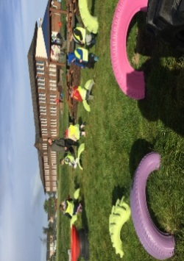

**Numeracy**

We are learning our numbers to 100. Practise sequencing these by clicking on the link below:

<https://www.topmarks.co.uk/ordering-and-sequencing/caterpillar-ordering>

Click on:

**Play game**

**Sequencing**

**Counting in 1s**

**0-100**



**Additional Information**

* Please return all homework and books on Friday in order for your pack to be given out again on Monday.
* Please keep your homework folder in your bag everyday (not the story book) as we often practise our sounds and words in the class.
* *Please practise your sounds and common words at home every day. It really helps you to learn these.

Gym days are

Wednesdays and Thursdays.

**Other Curricular Areas**

We are getting ready for our French assembly very soon. Please colour the flag in your pack in the correct colours or get creative with glitter/paint etc. It’s up to you what you use but your flag must have the right colours in the correct order. (See picture below): Let Mrs MacInnes know if you need some coloured pencils. I can’t wait to see your finished flags!



**Literacy**

* On return of your book from last week, you will get a new book to take home for the week ahead.
* Please read this and answer the questions with a grown up at home. Be ready to talk about your book with the class at the end of the week.
* We are revising ‘ch and ‘ng’ this week.
* Please practise reading and writing these. You can use your big yellow jotter to record your work.
* Practise all common words on the sheet in your pack from ‘a’ to ‘from’. Focus on the words that you find the most difficult.

**Things to Remember**

* Names should be clearly labelled on all personal belongings so that they can easily be returned if lost/misplaced.
* Bring a bottle of water to school every day. We can easily refill it if it runs out.

**P2 Homework**

**w.b: Monday 2nd October 2023**

**P1 Homework**

**w.b.Monday 4th September**