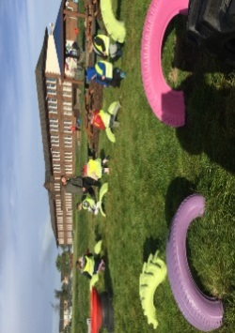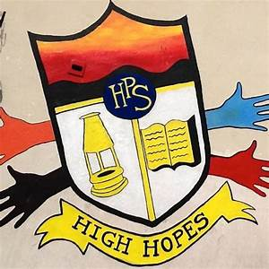

Gym days are

Wednesday and Thursday this week.

**P1 Homework**

**w.b: Monday 2nd October 2023**

**Additional Information**

* Please return all homework and books on Friday in order for your pack to be given out again on Monday.
* Please keep homework folders (not storybooks) in your bag every day as these are often used to practise sounds and common words.
* *Please practise your sounds and common words at home every day. It really helps you to learn these.

**Literacy**

* On return of your book from last week, you will get a new book to take home for the week ahead.
* Please read this and answer the questions with a grown up at home. Be ready to talk about your book with the class at the end of the week.
* Please practise our sound ‘n’ this week and revise s, a, t, p and i.
* Complete the ‘n’ activity sheet.
* Please practise ‘an’ and ‘is’ on your common word sheet and revise ’a’ ‘at’, ‘the’ ‘I’, ‘in’ and ‘it’.

**Things to Remember**

* Names should be clearly labelled on all personal belongings to that they can easily be returned if lost/misplaced.
* Bring a bottle of water to school every day. We can easily refill it if it runs out.

**Other Curricular Areas**

We are getting ready for our French assembly very soon. Please colour the flag in your pack in the correct colours or get creative with glitter/paint etc. It’s up to you what you use but your flag must have the right colours in the correct order (See picture below). Let Mrs MacInnes know if you need some coloured pencils. I can’t wait to see your finished flags!

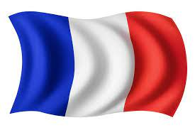

**Numeracy**

Can you play the game below and tell an adult what these shapes are:

* <https://www.topmarks.co.uk/early-years/shape-monsters>
* 

**P1 Homework**

**w.b.Monday 4th September**