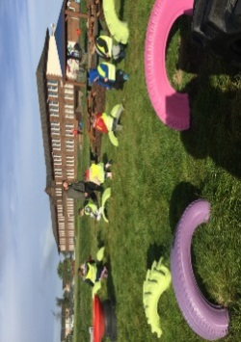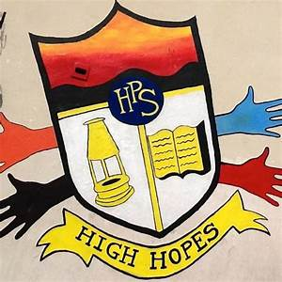

Gym days are

Tuesdays and Thursdays.

**P1 Homework**

**w.b: Monday 4th September 2023**

**Other Curricular Areas**

* For Health and Wellbeing, it is important that you learn to be independent. Can you put on your jacket and zip it up and can you put on your own shoes? When you can do that, you can try other things round the house, like making your own bed or setting the table.

**Numeracy**

* Make a set of numbers from 0 to 5 and order these.
* 

**Things to Remember**

* Names should be clearly labelled on all personal belongings to that they can easily be returned if lost/misplaced.
* Bring a bottle of water to school every day. We can easily fill it if it runs out.

**Literacy**

* You will have the chance to bring a storybook home with you this week. Please read this and answer the questions with a grown up at home. Be ready to talk about your book with the class at the end of the week.

**P1 Homework**

**w.b.Monday 4th September**

**Additional Information**

* Please return all homework by Friday in order for your pack to be given out again on Monday.