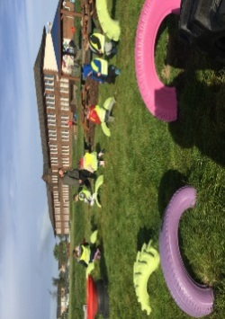

**Literacy**

* On return of your book from last week, you will get a new book to take home for the week ahead.
* Please read this and answer the questions with a grown up at home. Be ready to talk about your book with the class at the end of the week.
* Please practise the sound ‘a’ on the sound sheet.
* Complete the ‘a’ activity sheet.
* Please practise your first two common words on the sound sheet, ‘a’ and ‘at’

**Things to Remember**

* Names should be clearly labelled on all personal belongings to that they can easily be returned if lost/misplaced.
* Bring a bottle of water to school every day. We can easily refill it if it runs out.

Gym days are

Tuesdays and Thursdays.

**P1 Homework**

**w.b: Monday 11th September 2023**

**Other Curricular Areas**

-The weather was so lovely last week. Hopefully, we will see a little bit of sunshine in the week ahead. Go a walk with a grown up and tell them about your day and what your enjoyed doing at school.



**Numeracy**

* Please complete the dinosaur counting sheet.
* 

**P1 Homework**

**w.b.Monday 4th September**

**Additional Information**

* Please return all homework and books on Friday in order for your pack to be given out again on Monday.