Jog for 2 minutes, walk for 1 minute and repeat 1,2 or 3 times to improve your stamina.  Remember to breathe in your nose and out your mouth and jog…  slowly  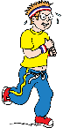 | Complete this mini fitness circuit. Work for 30 secs/1 min and rest for 1 min.  March on spot  Jumping jacks  Squats  Sit ups/crunches  Line jumps – sides and forwards and back.  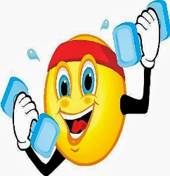  This Photo by Unknown Author is licensed under CC BY-NC-ND | Ball Skills  Pass the ball around your waist, knees, head.  Feet apart…  Roll or pass the ball through your legs in a figure 8.  Bounce and catch ball between legs 1 hand in front 1 hand behind….  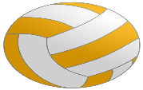  Change hands after each bounce. Try it without a bounce.  This Photo by Unknown Author is licensed under CC BY-SA | Create a short dance sequence and get someone to video it.  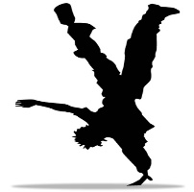  This Photo by Unknown Author is licensed under CC BY-NC-ND | Can you balance on 1 leg for 10/20/30 seconds or longer? Repeat on other leg.  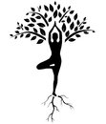
Football  Toe taps - ball in front tap the ball with alternate feet. How many taps in 30 secs?  Keepie uppie - How many times can you touch the ball whist its in the air using your feet, thighs or chest?  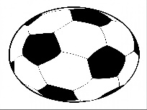 | Racket Sports  Keepie uppie –  Using a racket, tray, hardback book and small ball, shuttle, rolled up socks…  How many times can you hit the ball and keep it in the air…. add a bounce to simplify.  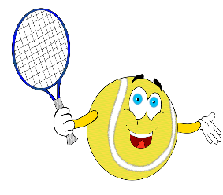 | Skipping  Practice skipping, get someone to help you if you are learning.  How many skips can you do?  See if you can beat your score.  How many skips can you do in 60 seconds?  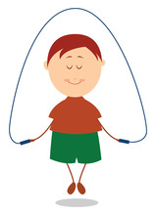 | Gymnastics  Can you balance in a shoulderstand for 10/20/30 secs?  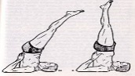 | Bounce Ball  Can you bounce/dribble the ball (hip height) with the palm of your hand and swap hands. How many bounces can you do in 1 minute?  Can you bounce the ball to the rhythm of a song?  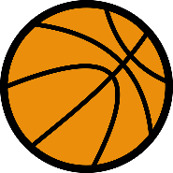
Go for a 10, 20 or 30 minute walk to improve your physical and mental health and wellbeing.  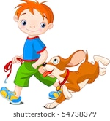 | Complete this mini fitness circuit. Work for 30 secs/1 min and rest for 1 min.  Jog with high knees  Jog with heel kicks  Wall sit in a squat position  Plank  Shuttle run between 2 markers  Jumping twists  This Photo by Unknown Author is licensed under CC BY-NC-ND | Roll a dice basketball  1 Throw and catch ball x 10,20,30  2 Chest pass against wall x 10,20,30  3 Bounce pass against wall x 10,20,30  4 Dribble ball using R and L hand x 10,20,30  5 Dribble ball between legs x 10  6 Shoot ball into hoop, bin, box, wash basket | Gymnastics  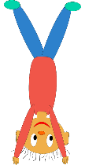  Can you perform a handstand against a wall or a door. Hands shoulder width apart, keep a strong straight balance, legs together and look at fingers… Kick up 1 leg at a time come down in reverse 1 leg at a time. | Football  Can you dribble the ball with your feet through a zig zag course (socks make great cones).  Can you kick the ball against the wall and count how many kicks?  Kick high and low.  Use both feet.  Can you kick the ball and hit a target on the wall?  Beat the goalie…  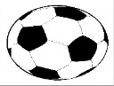
Racket Sports  Using a racket, tray, hardback book and small ball, shuttle, rolled up socks…  How many times can you hit the ball and keep it in the air….  Using forehand and backhand shots  Can you serve the ball and aim for a target eg bin, box, line on wall etc | Standing Long Jump  Get 2 markers and a tape measure…use a rope, piece of string, wool, tie, etc.  Get ready…like a skier…swing arms forwards and back in preparation (not your hips). Push off on 2 feet using legs and arms and land on 2 feet.  Measure distance from the furthest point back…probably your heels…  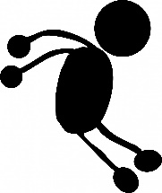 | Ball Skills  Can you  Roll a ball through goals x 10,20,30  Throw and catch a ball x 10,20,30  Throw, clap and catch a ball…how many times?  Bounce a ball no higher than hip x 10,20,30  Kick a ball through goals x 10,20,30  Shoot with hands and score in hoop, bin, box, wash basket.  This Photo by Unknown Author is licensed under CC BY-SA | Roll a dice fitness  1 Jumping jacks x 10,20,30  2 Sit ups or crunches x 10,20,30  3 Push ups form knees/feet x 10,20,30  4 Jog on spot for 30 secs/1 min  5 Hops on each foot 5,10,15  6 Squats x 10,20,30  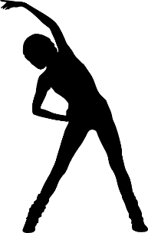 | Dance/Gymnastics  Create a gymnastics sequence using  rolling, jumping, balancing and hands and feet skills.  Create a dance sequence using travelling, stillness, jumping, arm movements, facial expression to your favourite piece of music.  Video and share.  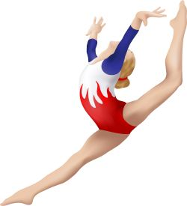  This Photo by Unknown Author is licensed under CC BY-ND

