
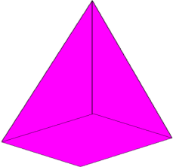
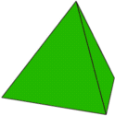

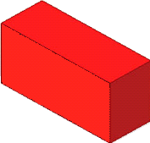
A
mATCH tHE nETS
B
C
D
E
F
G
Can you match the correct net with its 3D shape?
1
5
4
3
2
A
mATCH tHE nETS
B
C
D
E
F
G
Can you match the correct net with its 3D shape?
1
5
4
3
2

Net | Shape
 | 1
 | 2
 | 3
 | 4
 | 5

Net | Shape
 | 1
 | 2
 | 3
 | 4
 | 5

