Find out what your name means.  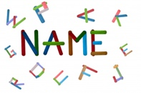 | Plant a potato that is starting to go bad… remember to water it – you can grow more potatoes! | Keep a note of the time that you get up at and go to bed at for the rest of the week.  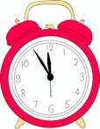 | Explain to someone at home what adjectives and nouns are. | Get building!  Build a tower out of lego, playing cards, tins of food or something else! How tall is your tower? Can you make any design alterations?
Enjoy playing a game with your family: snakes and ladders, dominoes, cards, eye-spy? | Can you find the numbers 0-20 written in different places (at home or out and about? | Share half of something delicious with someone in your house | Write the first names of the people in your family in alphabetical order  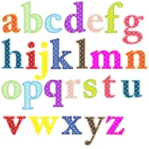 | Start a nature diary. Look out of your window or around your garden. Keep a note of what you see: birds, flowers, changes in weather, what else?
Help make a meal for your family. | Cut out the letters of your name from different places (newspapers / magazines, etc) | Find a cube, cuboid, cone and sphere!  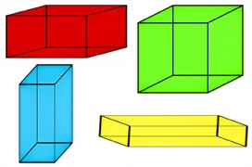 | How many times can you say the alphabet without making any mistakes in 1 minute? | Do something kind for someone. Can you pay them a compliment, make them something, or help with a task?
Add up the numbers in your phone number. Do the same with a friend’s. Make as many combinations as you can. | What is a gift that can you can give that doesn’t cost any money? Write about what this could be, who you would  give it to and why, | Ask someone in our family to teach you their favourite game and play it together.  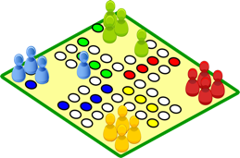 | Look out your window, write as many adjectives as you can to describe what you see | Create a story bag. Find a bag and collect things that relate to a story you know well. If you can’t find items, you could draw pictures to include in your story bag.
First Level
Useful Resources:

Balls, Pasta, Laces, Salt, Flour, Blankets, Sheets, Chalk, Washing Up Liquid, Straws, Books, Music, Lego, Toilet Rolls, Old Boxes, Paper, Colouring pencils, Books
Learning through play is important at any age. It helps children develop the skills they need to succeed in school and in future life
Have a look and see what you can play today!

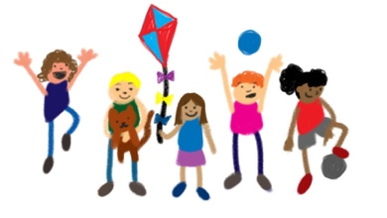

You can keep a record of your learning in a notebook, on your GLOW Blog, take photographs, use the ‘Home Learning Diary’ … or in any other way you can think of!
You can keep a record of your learning in a notebook, on your GLOW Blog, take photographs, use the ‘Home Learning Diary’ … or in any other way you can think of!

Next time someone cooks with an onion, keep the top bit with the roots. Leave to dry for a few days and then plant in your garden – more will grow! | Practise saying the stations of four times tables forwards and backwards. Ask someone to time you.  Try to improve your time. | How many days in May? List the months that have the same number of days.  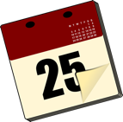 | Make a list of all the everyday objects in your house which are cuboid shape.  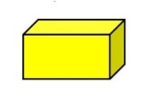 | Write a list of things that make you happy, things you are grateful for, or things you are good at ….  Celebrate YOU!!!!
Record the weather over a week. Make a table to record your results using weather symbols. | Ask someone in your family to describe their favourite teenage fashion. Draw a picture to illustrate it. | Set the table for a meal and share a meal with a member of your family.  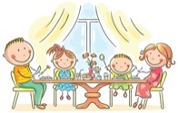 | List 10 words that describe you. List 10 words that describe another member of your family. | Keep moving and grooving!  Make up a dance routine to your favourite song.  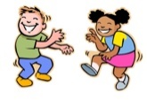
Describe and discuss a favourite book character. Tell what you like about this character.  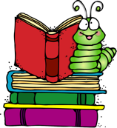 | Ask someone to put some items on a tray. Look at them for 2 mins then cover. How many can you remember?  Ask someone to change the items or take some away … try again! | Put rice or pasta in a container. Add a sppon of vinegar and some food colouring – shake well and leave to dry,  Ypu can build your own magic land for your toys to explore | How many things can you name from a category?  Thihngs to drink, zoo animals, dinosaurs, things that fly, animals that can swim, etc | Make some bubble mixture from water and washing up liquid. You can make bubble wands from straws, coat hangers, paper clips
Play the ‘what if…? Game.  Tell someone or write your ideas.  Eg. WHAT IF..  You could fly?  The house was made of cheese? | Build a mini cty with boxes, sticks, twigs, rocks, or any other interesting things you can find. | Set up a calm corner. This can be your special place to read, relax and play | Write a postacrd to your teacher. Can you tell them what you like about school and your class.  Your teachers miss you too! | Can you invent something new? Perhaps a gadget to help people? Draw a picture or write a description…you could even make a junk model!
You can keep a record of your learning in a notebook, on your GLOW Blog, take photographs, use the ‘Home Learning Diary’ … or in any other way you can think of!
Useful Resources:

Balls, Pasta, Laces, Salt, Flour, Blankets, Sheets, Chalk, Washing Up Liquid, Straws, Books, Music, Lego, Toilet Rolls, Old Boxes, Paper, Colouring pencils, Books
Learning through play is important at any age. It helps children develop the skills they need to succeed in school and in future life
Have a look and see what you can play today!

