Early Years Dinner Menu 2025/26 – Week 3
Monday | Tuesday | Wednesday | Thursday | Friday
 | 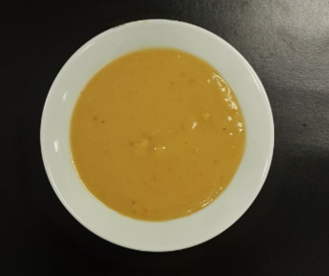 |  | 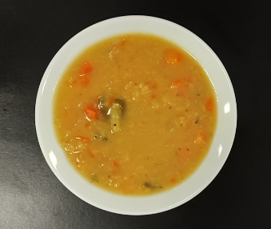 | 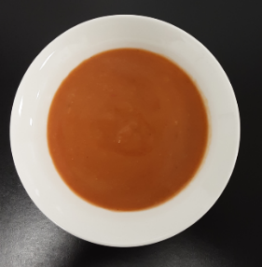
 | Vegetable soup |  | Lentil soup | Tomato soup
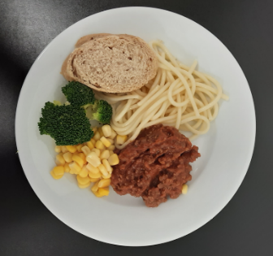 | 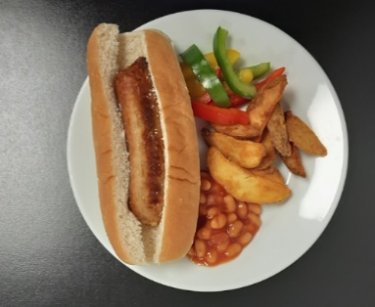 | 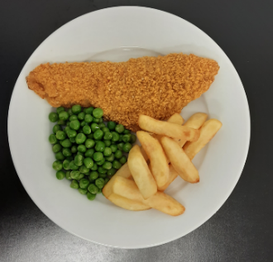 | 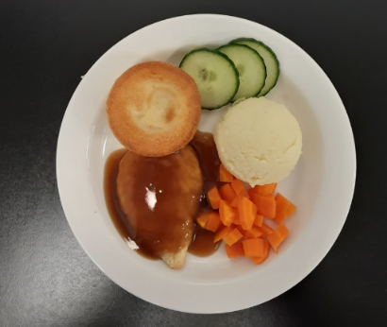 | 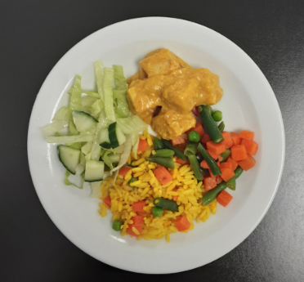
Pasta bolognese with crusty bread, broccoli & sweetcorn | Sausage sizzler & potato wedges with beans & sliced peppers | Oven baked fish & chips with peas & tomato | Roast chicken, Yorkshire pudding, mashed potato with carrots & cucumber | Chicken korma with golden rice, mixed vegetables & green salad
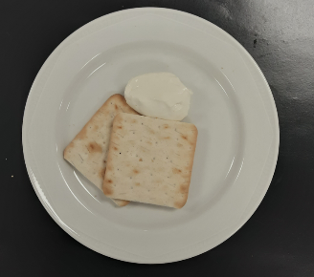 |  | 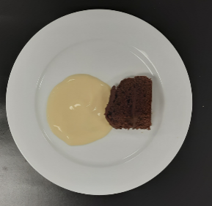
Crackers & cheese (V) |  | Chocolate raspberry sponge & custard (V)

