Early Years Dinner Menu 2024/25 – Week 2
Monday | Tuesday | Wednesday | Thursday | Friday
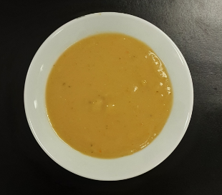 |  | 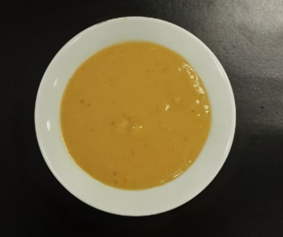
Super Tattie soup |  | Vegetable soup |  | Super Tattie soup
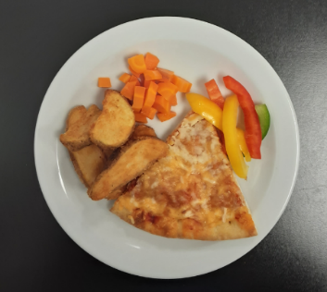 | 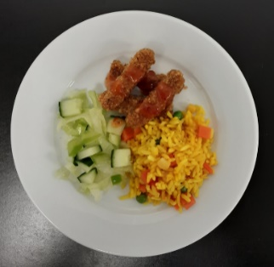 | 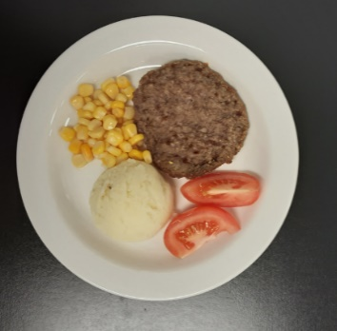 | 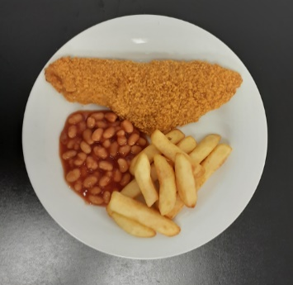 | 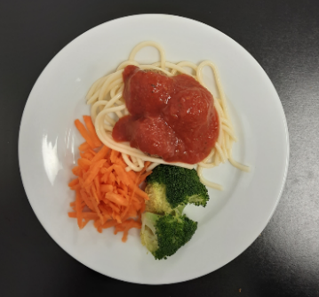
Cheese & tomato pizza & potato wedges with carrot & sliced peppers (V) | Bang Bang chicken fries with vegetable rice & green salad | Beefburger & mashed potato with sweetcorn & tomato | Oven baked fish & chips with beans & cucumber | Meatball marinara spaghetti with broccoli & grated carrot
 | 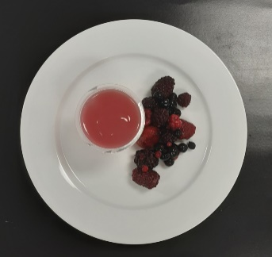 |  | 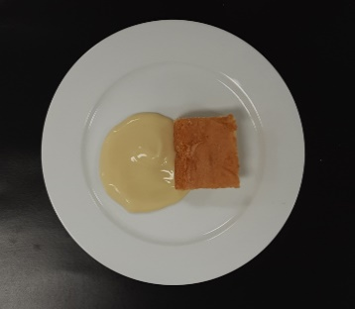
 | Jelly & fruit (V) |  | Vanilla sponge & custard (V)

