Early Years Dinner Menu 2025/26 – Week 1
Monday | Tuesday | Wednesday | Thursday | Friday
 | 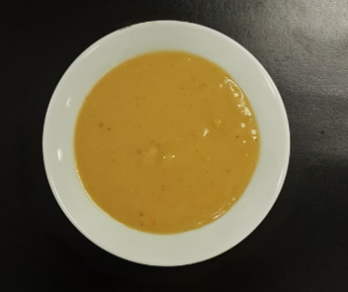 |  | 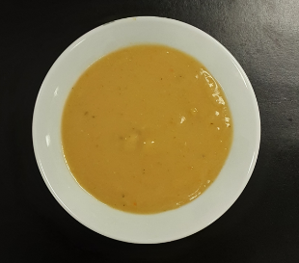 | 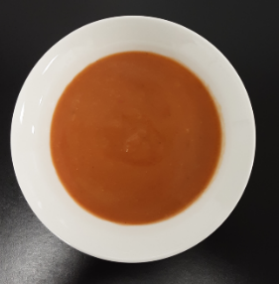
 | Vegetable soup |  | Super Tattie soup | Tomato soup
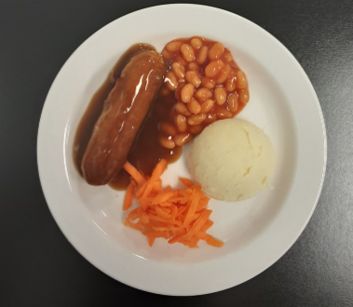 | 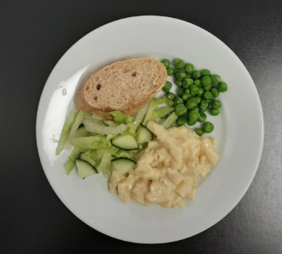 | 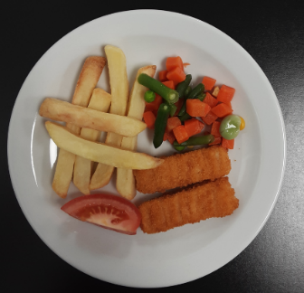 | 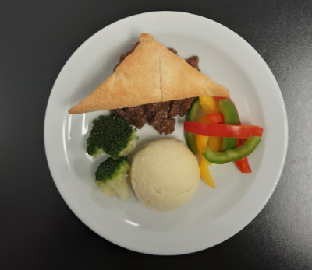 | 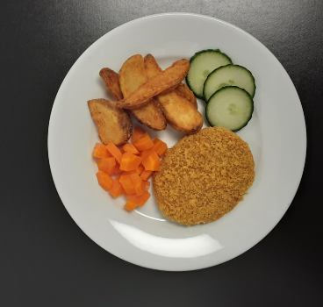
Pork sausages with gravy, mashed potato, beans & grated carrot | Macaroni cheese with crusty bread, peas & green salad (V) | Salmon fingers & chips with mixed vegetables & tomato | Steak mince pie & mashed potato with broccoli & sliced peppers | Oven baked crispy chicken & potato wedges with carrots & cucumber
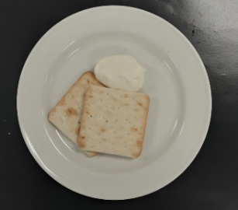 |  | 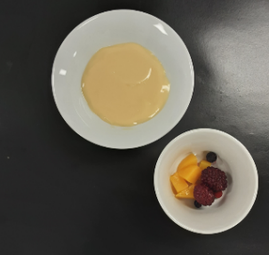
Crackers & cheese (V) |  | Custard & fruit (V)

