Early Years Lunch Menu 2024/25 – Week 3
Monday | Tuesday | Wednesday | Thursday | Friday
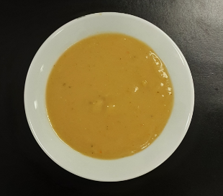 |  |  |  | 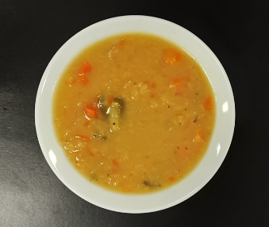
Super Tattie soup (V) |  | Vegetable soup (V) |  | Lentil soup (V)
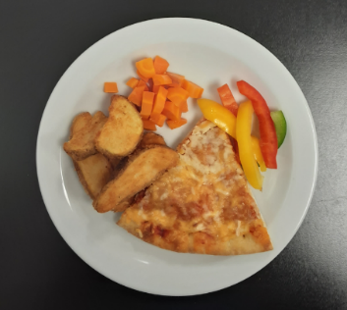 | 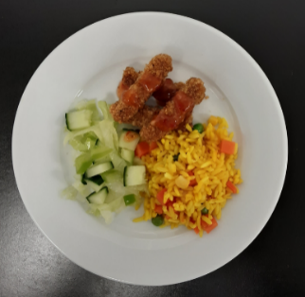 | 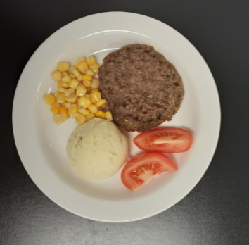 | 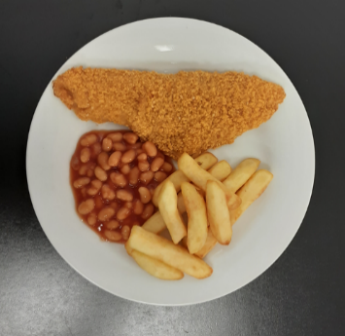 | 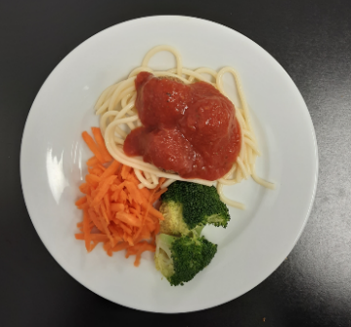
Cheese & tomato pizza with potato wedges, carrot & sliced peppers (V) | Bang Bang chicken fries, with vegetable rice & green salad | Beefburger & mashed potato with sweetcorn & tomato | Oven baked fish & chips with beans & cucumber | Meatball marinara spaghetti with broccoli & grated carrot
 | 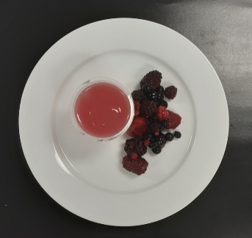 |  | 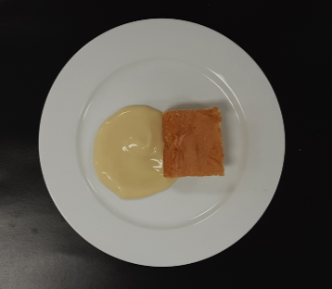
 | Jelly & fruit (V) |  | Vanilla sponge & custard (V)

