Early Years Lunch Menu 2025/26 – Week 2
Monday | Tuesday | Wednesday | Thursday | Friday
 | 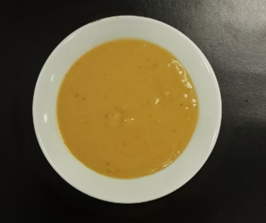 |  |  | 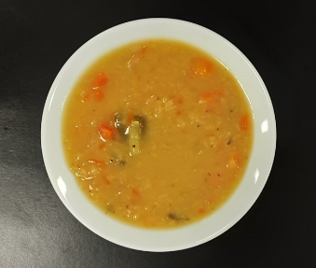
 | Vegetable soup (V) |  | Super Tattie soup (V) | Lentil soup (V)
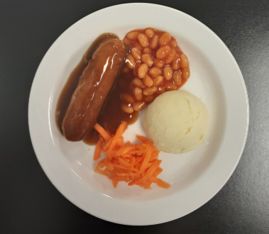 | 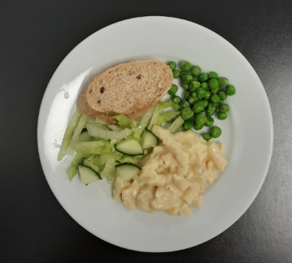 | 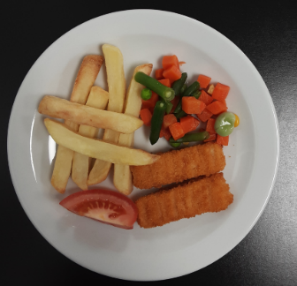 | 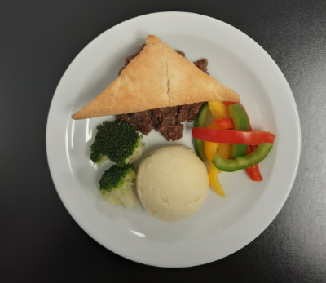 | 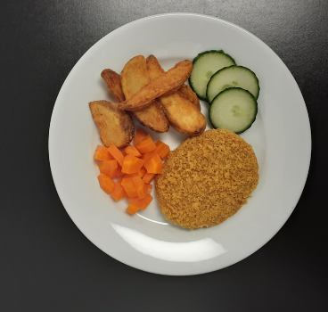
Pork sausages with gravy, mashed potato, beans & grated carrot | Macaroni cheese & crusty bread with peas & green salad (V) | Salmon fingers & mashed potato with mixed vegetables & tomato | Steak mince pie & mashed potato with broccoli & sliced peppers | Oven baked crispy chicken & potato wedges with carrots & cucumber
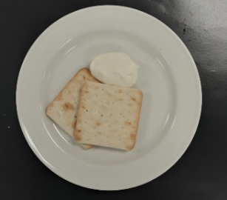 |  | 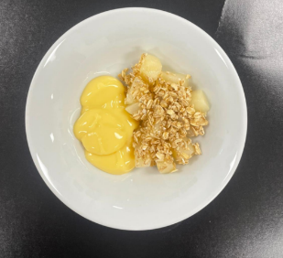
Crackers & cheese (V) |  | Baked apple crumble & custard (V)

