Early Years Lunch Menu 2025/26 – Week 1
Monday | Tuesday | Wednesday | Thursday | Friday
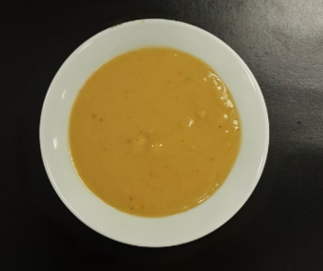 |  |  |  | 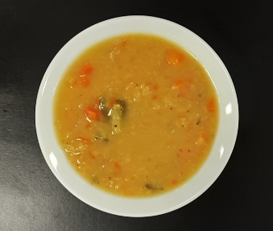
Vegetable soup (V) |  | Super Tattie soup (V) |  | Lentil soup (V)
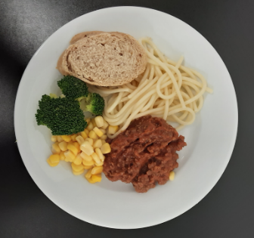 | 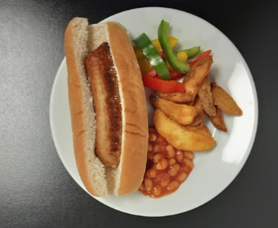 | 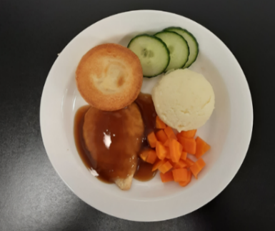 | 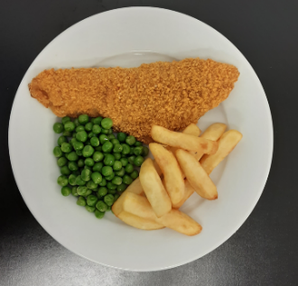 | 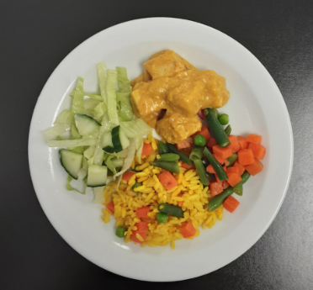
Pasta bolognese with crusty bread, broccoli & sweetcorn | Sausage sizzler with potato wedges, beans & sliced peppers | Roast chicken, Yorkshire pudding, mashed potato, carrots & cucumber | Oven baked fish & chips with peas & tomato | Chicken korma & golden rice with mixed veg & green salad
 | 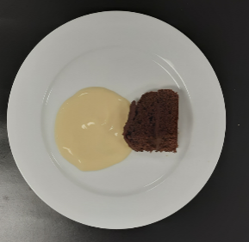 |  | 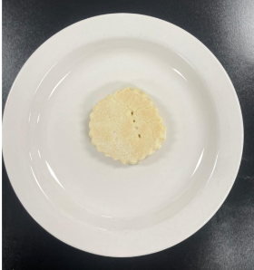
 | Chocolate raspberry sponge & custard (V) |  | Shortbread (V)

