 **Galston Early Childhood Centre**

**August 2024 Newsletter!**



We would like to take this opportunity to welcome everyone to Galston Early Childhood Centre, whether you are returning following the summer break or just starting your journey with us. We are looking forward to a fantastic year ahead!

**Meet the Team!**

We recognise that you will meet lots of different staff over the next few weeks, so we hope this will help you to recognise staff within both rooms. We would like to welcome both Cheryl McCubbin and Leah Hamilton to the team.



**Rainbow Room Staff (2 -3 year olds)**



Rebecca, Lynsey, Alice, June (Left to Right)

**Butterfly Room Staff (3-5 year olds)**



 **Blue Group Red Group**



**Irene Sayers and Irene Craig** **Cheryl Williamson and Kelly McMullen**

**Purple Group Green Group**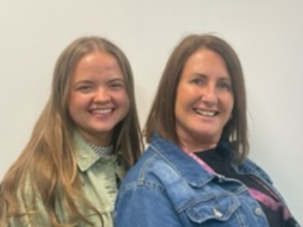 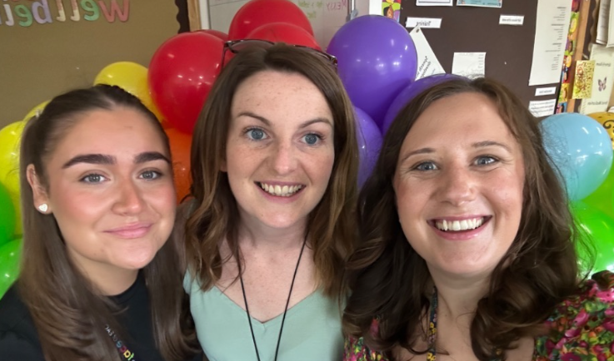

**Leah Hamilton and Alyson Paterson Jenna Law, Rebecca Baird & Hazel Kerr**

**Yellow Group**

 

**Cheryl McCubbin, Lauren Dean and Joanne Lyon**

Clerical Assistant Good Luck to Rachael!

 

We would like to wish Rachael all the very best as she starts her maternity. We are all looking forward to meeting “Bump”!

**Joanne Ward**

**Our Values – Meet our Star of the Week Mascots**

Following parental and child discussion last year our values were agreed as Respect, Resilience, Kindness and Confidence. To support the children’s understanding of the values, we have developed value mascots with associated stories to support learning and understanding of the values we feel are important within the Centre. When children demonstrate, these values they will receive a Star Ticket which will go towards achieving a Star of the Week Certificate. Parents/Carers will be able to read the reason their child achieved the individual star tickets on their certificate and can celebrate their achievements with them.

**Meet our Value Mascots**

 Cooper the **Confident** Cow Rolo the **Resilient** Rhino

Konnie the **Kind** Kangaroo  Rex the **Respectful** Raptor

**Routines**

We know that children thrive on having routine and predictability within their day to support them to feel safe and secure. We aim to support consistency of routine within the Centre by using visual information within the playroom which children can refer to during their session.

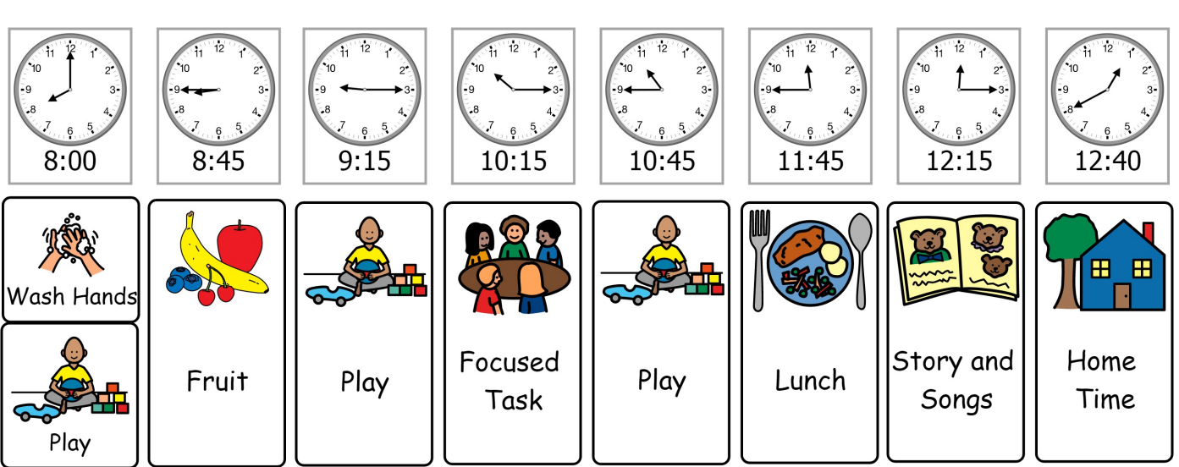 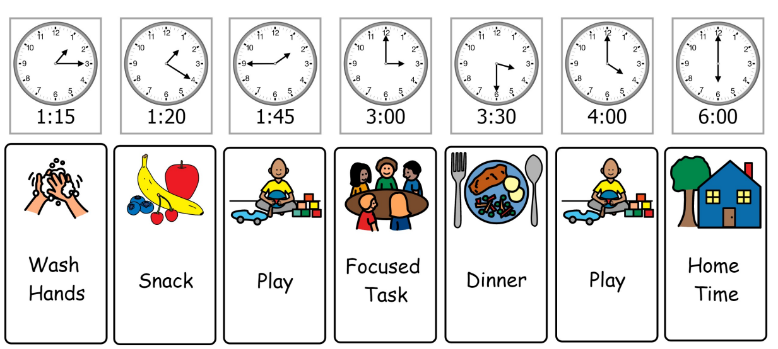

**Morning Routine Afternoon Routine**

**RAG Bag Collection**

We have arranged the next collection for **Monday 9th September**. The bags are weighed and money is received which the Centre can use to purchase resources or support outings. All bags, containing clothing, paired shoes, handbags, ties and belts can be brought into the Centre by Friday 6th September.

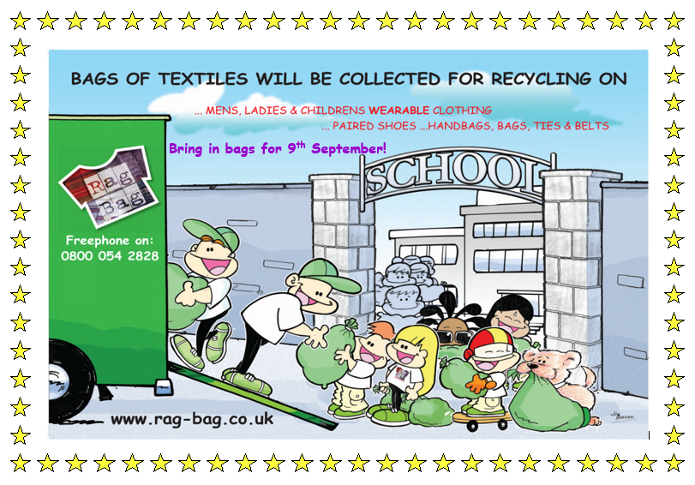

**Dates for the diary: September Weekend**

The Centre will be closed for all children on Friday 20th and Monday 23rd September for the local holiday. We hope to confirm key dates in the September newsletter.

**Learning Journals**

All parents/carers should have access to their child’s learning journal. Information on the journal will document your child’s learning within the Centre through observations which support next step targets. General information, in the form of stories will also be included on the journals to share events, reminders and the newsletter. If you require any support in accessing your child’s learning journal please let your child’s keyworker know. All observations will be published weekly on Friday at 6pm.

**Contact us!**



**Phone:** You can contact the Office on: 01563 820360

**Email:** Head of Centre: [dawn.waide@eastayrshire.org.uk](mailto:dawn.waide@eastayrshire.org.uk)

Depute Manager:[elaine.bowden@eastayrshire.org.uk](mailto:elaine.bowden@eastayrshire.org.uk)

You can also contact your child’s keyworker directly through the Learning Journals.