**Galston Early Childhood Centre:**

**Newsletter: 26th August 2022**

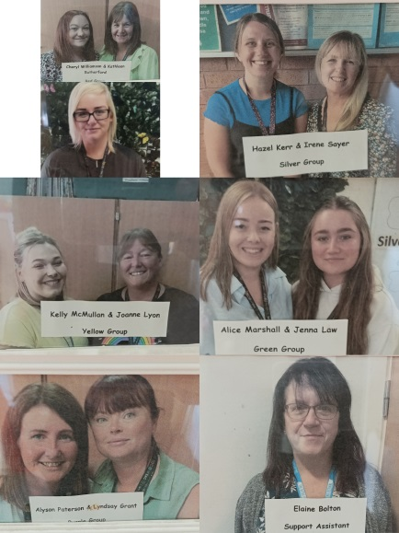

Butterfly Room Staff

Rainbow Room Staff

**Welcome to all!!**

A warm welcome to everyone starting back the ECC and our new children! A special welcome to all adults that can come into the ECC! Below are the staff members you and your child will see when in the centre, their pictures are up in the cloakroom when you enter the ECC. Some new faces are Martin McMullen and Lynsey Ferguson both are in as Seniors, Cheryl Williamson who is in the Red group in the Butterfly room and Mechelle Thomson who is covering in the Rainbow room until the arrival of June Nisbet.

Management

& Clerical

**Snacks/allergens**

We insist that **no snacks and drinks** are in your child’s bag before bringing them into the centre.

We have many allergens in the ECC and are trying to mitigate against any potential risks that we can where possible.

If you have a previous agreement with staff where your child has to bring a lunch in due to allergy reasons then this will be taken into consideration.

**Rainbow Room**

**Morning Session:** A morning session runs from 8am – 12.45am. A member of the management team will be at the main gate when you arrive with your child at 8.00am. A member of the Rainbow Room staff team will meet you at the entrance to the Rainbow courtyard. Collection time is 12.45pm, a member the management team will greet you at the main gate, and you will be able to collect your child in the Rainbow playroom. Staff will be able to give you a brief overview of your child’s day and answer any questions you may have. A member of the management team will be at the main gate to ensure the safety and security of all during this hand over period.

**Afternoon Session:** An afternoon session runs from 1.15pm – 6.00pm. A member of the management team will be at the main gate when you arrive with your child at 1.15pm. Staff from the Rainbow Room will greet you at the gate to the Courtyard where you will be able to share any specific care needs for your child. Please give an indication of when you will collect your child, so that staff can support the child and make preparations for their collection. At time of collection, please ring the ECC buzzer at the main entrance to the school and either clerical staff or a member of the management team will accompany you to collect your child in the Rainbow playroom.

**Butterfly Room**

Welcome parents!! We have a new system in place at drop of and pick up:

**Morning children** drop off 8-8:50am through main door to Primary School – parents

to bring child in and sign in

Pick up at 12:45 from ECC side door

**9-3 children** Drop off 8:50-9:10 at ECC side door using one way system

Pick up at 2:50 – 3:10 at ECC side door using one way system

**Afternoon Children** Drop off 1:15 at ECC side door

Pick up 4:30-6pm through main door to Primary School – parents

to come in and sign child out

A reminder that unfortunately we cannot allow prams into the centre but please bring any siblings or younger ones out and they can come in with you to drop off or pick up!



Outdoor play in all weathers

Please be mindful that children are out no matter the weather as they get to choose where they play and learn.

With this in mind, if it is really warm and sunny can you ensure loose baggy clothing and putting suncream on children before arriving.

If it is very cold please ensure to have layers for the children of T.shirt, jumper, fleece or jacket for example.

If very wet please ensure that your child has suitable clothing and changes of clothes.

**Spare Clothing**

Please always pack spare clothes in your child’s bag in case of any toileting accidents, outdoor play or messy play in the centre. This includes underwear and socks. Socks are most often what need changed if the children have been outdoors exploring & splashing in puddles.

Could **All Clothing** have the child’s name on them including shoes and wellies to avoid any being misplaced.

**Butterfly Room** - Any wellies coming to the ECC please bring these in and put them in the coloured buckets as you enter the ECC. The colour matches the group colour (Silver group is the black!). This enables us to promote your child’s independence to change themselves for outdoor play.

**Safety**

Could we please encourage all parents/carers to hold hands with their child when arriving to and leaving the centre. It is often quite a populated area as we have the school children also getting dropped off and picked up and a busy car park quite close to the gates. We want everyone to remain safe whilst attending Galston ECC.

Also for safety of children’s belongs we ask that **no toys from home** come into the ECC. We unfortunately cannot guarantee their safety and may get lost or broken.

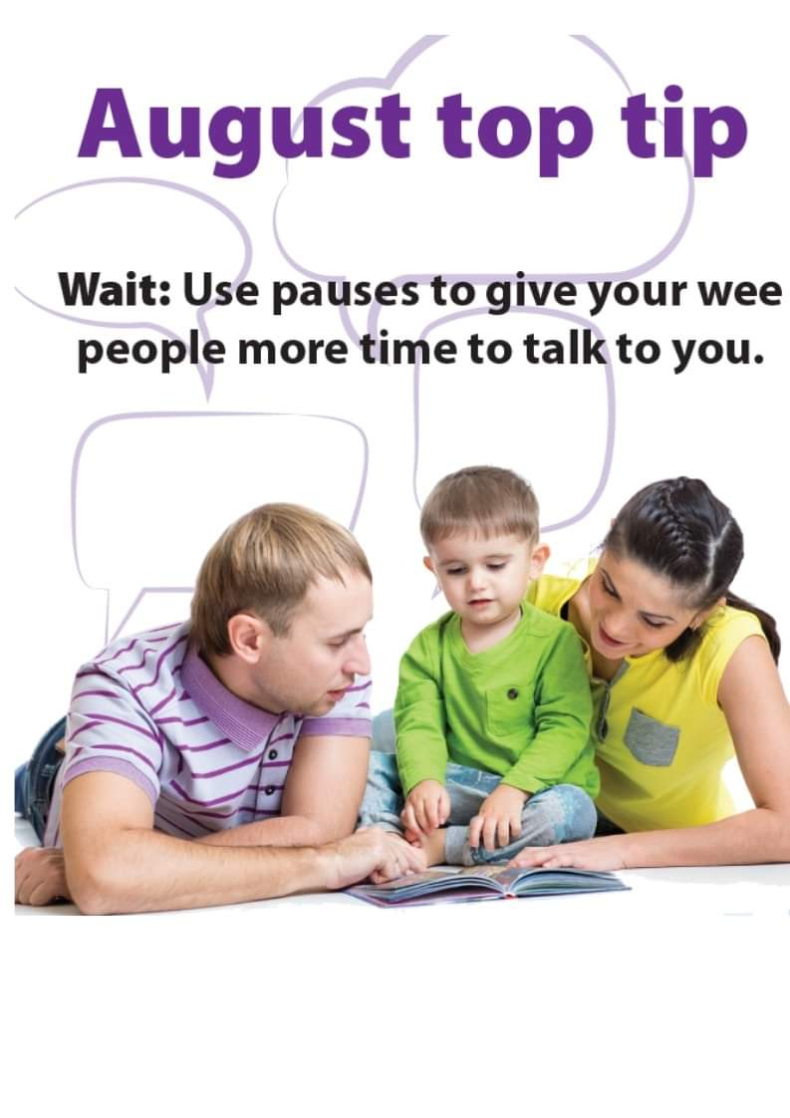



Check out the poster to the right for advice on how to best support your child’s communication skills.

Check out the poster to the left for our August communication top tip!

**Proposed Autumn Event Calendar 2022 -2023**

|  |  |
| --- | --- |
| **September** | |
| Monday 19th | Local Holiday – ECC Closed |
| Tuesday 20th | Children return to nursery |
| Wednesday 21st | Coffee & Chat with DM (9am: Early DM / 1.15pm Late DM) |
| Friday 23rd | Celebration of Harvest through songs. |
| **October** | |
| Week of the 3rd | Cauliflower Cards (fundraiser for Christmas) |
| Thursday 6th | ECC Individual Photographs |
| Friday 17th | Last day for term time children before mid-term break |
| Monday 17th – Friday 21st (inclusive) | Mid-term holiday for Term Time children |
| Monday 24th | ECC closed: Staff In service Day |
| Wednesday 26th | Coffee & Chat with DM (9am: Early DM / 1.15pm Late DM) |
| Friday 28th | Halloween Celebrations & Pumpkin Trail |
| Monday 31st – 4th November | Parental Meetings – Care Plan updates |
| **November** | |
| Friday 18th | PJ’s for Pudsey. Children in Need event. |
| Wednesday 28th | Coffee & Chat with DM (9am: Early DM / 1.15pm Late DM) |
| Friday 30th | St. Andrews Celebrations – stay & play event |
| **December** | |
| Week Beginning 12th – 16th | Christmas Stay & Make Decoration Sessions / Xmas book bug  Information to be shared once confirmed |
| Tuesday 20th | Christmas Celebration TBC |
| Thursday 22nd | Christmas Parties (am/pm children) Perhaps a Special Visitor! |
| Friday 23rd | Last day of term for all children |
| **January 2022** | |
| Wednesday 4th | Non Term Time children return to centre |
| Monday 9th | Term Time children return to Centre |

**Galston School and ECC APP**

Please download this app onto your phone. The App is free, simply search for PSA in the Apple or Google Play app stores. The APP has a section for the Early Childhood Centre as well as each year group from the school. You can select to receive information for specific groups. All information for the school and ECC regarding updates and events is communicated through this APP.



**Please Contact us by:**

**ECC Telephone:** 01563 820360

**Email Headteacher:** [shona.murphy@eastayrshire.org.uk](mailto:shona.murphy@eastayrshire.org.uk)

**Email Deputy Manager**:[elaine.bowden@eastayrshire.org.uk](mailto:elaine.bowden@eastayrshire.org.uk)

**Twitter**: @GalstonECC

**E- Journals:** You can message your child’s keyworker through the E-journals.