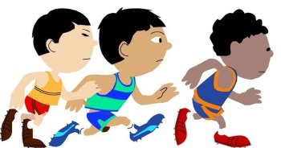**C:\Program Files\Microsoft Office\MEDIA\CAGCAT10\j0301480.wmfRainbow Room Health Week   
14th – 18th June**

Throughout health week we will promote things we can do to have a balanced healthy lifestyle.   
The activities below will be on offer for all children to take part in, if they want, throughout the free flow of the session.   
We will update learning journals and our GLOW blog throughout the week to include you in sharing the fun.

|  |  |  |  |  |  |
| --- | --- | --- | --- | --- | --- |
| **ZONE A** | **Monday** | **Tuesday** | **Wednesday** | **Thursday** | **Friday** |
| **Walk to School Week** | Wear a hat or sunglasses | Happy Shoesday | Wear bright clothes or accessories | Wear odd socks | Crazy hair day! |
| **Snack** | Fruit Kebabs | Veggie sticks and dips | Yoghurt and fruit | Smoothies | Ice lolly/Ice pole |
| **Activity** | **C:\Users\kenneyc\AppData\Local\Microsoft\Windows\INetCache\Content.MSO\E3FF07F5.tmpYoga** | **Obstacle course** | **Walking**  **C:\Users\kenneyc\AppData\Local\Microsoft\Windows\INetCache\Content.MSO\6A096211.tmp** | **Smoothie making**  **C:\Users\kenneyc\AppData\Local\Microsoft\Windows\INetCache\Content.MSO\2D37B583.tmp** | **Road Safety**  C:\Users\kenneyc\AppData\Local\Microsoft\Windows\INetCache\Content.MSO\E53085F6.tmp |

**C:\Program Files\Microsoft Office\MEDIA\CAGCAT10\j0301480.wmf**