**Flowerbank ECC - Infection Control Policy**

**Who’s Responsible?**

1. It is the overall responsibility of the SMT to ensure that the setting adheres to all infection prevention and control expectations to ensure children, staff and visitors are kept safe when in the ECC.
2. It is the responsibility of the SMT to ensure that staff understand how infections spread. The chain of infection is used to describe how germs spread (see diagram at the end of the policy).
3. It is the overall responsibility of the SMT to ensure that all staff fully understand the procedures outlined within all central policies (Health and Safety policy, Changing procedures/risk assessment and Food policy), the PHS guidance ‘Health Protection in Children and Young People settings, including education’.
4. It is the responsibility of all staff to promote good hygiene, ensuring areas are cleaned properly and the correct measures are taken to ensure that the spread of infection is minimised at all times. Consideration should also be given to the Hierarchy of Controls (HoC).
5. It is the responsibility of all staff to care for children attending the service. In the event of a child becoming unwell or injured, staff must follow appropriate infection prevention and control procedures at all times.

**How will this policy be implemented?**

1. Although we cannot stop all infectious diseases, there are ways to reduce how often we get sick, how often we pass on infections to others and how to reduce serious diseases through good health protection and infection control within the ECC. This policy should be read in conjunction with all policies outlined in point 3 above and fully implemented.
2. **Arrangements for hand washing:**

Staff/children should wash hands at the following times:

* + On arrival at the centre
  + After blowing noses, coughing or sneezing
  + Before and after eating
  + After using the toilet / nappy changing
  + After touching animals and pets
  + On return from outdoor play
  + When hands are visibly dirty
  + On return from breaks (staff)

Where possible staff and children should always wash their hands using warm running water and liquid soap and hands should be dried thoroughly using paper towels. Communal bowls with shared water should never be used when washing hands and a designated, lined bin that the children can operate easily should be provided for disposal of hand towels.

When participating on an outing and there is no running water available, hand wipes may be used as a short term measure, however children and staff should wash their hands with soap and water at the first available opportunity.

Pictorial handwashing routines should be displayed at sink areas for both children and staff. Staff must ensure that paper towels and soap are easily accessible and available at all times.

1. **Staff hygiene:**

Staff should refer to the food policy in relation to hand hygiene when preparing food. If staff have nail varnish/acrylics or cuts or abrasions, they should always wear gloves when preparing food. The wearing of wrist jewellery (including watches), false nails and nail products are not recommended for staff involved in preparing foods. It is not necessary for staff to wear gloves and aprons when assisting children during mealtimes, staff should ensure they wash their hands before sitting at the table with children. There is also no need for staff to wear aprons or gloves when involved in transporting food from the kitchen/trolley to the tables. If staff feel that they are posing a particular risk to the safety of the children, then they can choose to wear PPE on these specific occasions (see Food policy for more information).

PPE should always be worn when preparing food, dealing with spillages and waste as well as when changing nappies, please refer to each policy for specific expectations. To be effective, PPE needs to be used correctly which means putting it on and removing it correctly and safely.

Staff should ensure they report their own sickness to management in relation to infectious diseases and adhere to exclusion timescales as set out in the PHS guidance ‘Health Protection in Children and Young People settings, including education’ within the section- managing specific infectious diseases; A to Z.

Any individuals suffering from sickness and/or diarrhoea should not be involved in food preparation until at least 48 hours after symptoms have stopped.

1. **Respiratory and Cough Hygiene**

Staff must model/encourage good respiratory and cough hygiene by:

* covering their nose and mouth with a tissue when coughing and sneezing, disposing of used tissue in a waste bin, and then washing their hands.
* coughing or sneezing into their inner elbow (upper sleeve) if no tissues are available.
* keeping contaminated hands away from their eyes, mouth and nose.
* washing hands with soap and water after contact with respiratory secretions and contaminated objects and materials.
* Staff must ensure tissues, and a waste bin are easily accessible to children.

1. **Nappy changing/potties:**

Management should ensure procedures are in place for nappy changing/standing change. Step by step guidance should be displayed for staff within the nappy changing/changing areas. Guidance should be laminated and positioned for ease of reference. Procedures should consider the privacy and dignity of the child as well as the infection control practices that staff most follow.

All potties should be sprayed with anti-bacterial solution and dried using disposable paper towels after every use. Settings must consider how they will safely store potties while not in use. Staff must refer to the Changing Children risk assessment at all times.

If potties are used, facilities for cleaning and storage must be available. Staff should not wash potties in a designated hand washing sink and potties must be stored out of the reach of children when not in use. If a separate sink for potties is not available, the sink used must be cleaned thoroughly after use with an appropriate solution.

1. **Cleaning Arrangements:**

All areas within the setting which are considered high risk (areas or surfaces in contact with food, dirt, or bodily fluids) of germs being present should be cleaned with appropriate solutions on a regular basis. Areas should remain clutter free where possible. A member of the SMT should spot check regularly to ensure cleaning arrangements are in place and being adhered to by all staff.

A cleaning schedule should be in place and maintained by staff. This schedule should, describe the cleaning methods being used, the areas and items to be cleaned, the frequency of cleaning and the name of the staff member undertaking the cleaning.

Toys and equipment should be safe for use, easily cleaned and well maintained to reduce the risk of germs spreading. Toys and equipment should be cleaned regularly as part of the cleaning schedules in place, if visibly contaminated, between use (where possible) and before or after any servicing or repair.

Soft toys should be regularly cleaned following the manufacturers’ instructions. It is recommended that all soft toys in the setting are machine washable. Soft toys that are not machine washable should be hand washed using general-purpose detergent and hand-hot water, rinsed and dried.

The SMT should ensure that all staff are aware of the environmental cleaning schedules and their individual responsibilities.

Where applicable, the SMT must ensure staff are appropriately trained in the use of cleaning products and have access to the appropriate personal protective equipment (PPE).

It is not recommended that spray bottles for cleaning products are refilled as there is a risk of contamination. However, to reduce costs and to protect the environment, refillable bottles will continue to be used in ECCs. It is therefore essential that bottles are cleaned thoroughly (minimum of 1x weekly) when the solution is refilled. Particular attention should be given to the trigger and nozzle of the spray bottle.

A termly infection control audit should be carried out by the SMT to ensure any necessary actions can be taken to maintain a safe and clean environment.

Staff should also reduce opportunities for germs to survive by ensuring fixtures, fittings and equipment are in good repair and can be easily cleaned. Rooms should be kept well-ventilated. Letting fresh air into indoor spaces will help dilute air that contains viral particles and reduce the spread of many infections.

Tables used for mealtimes, must be cleaned following a two-step cleaning process:

# Stage 1 Suma Multi D2.3 SmartDose

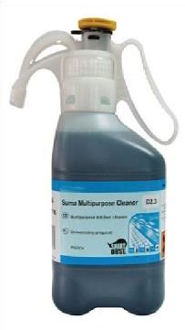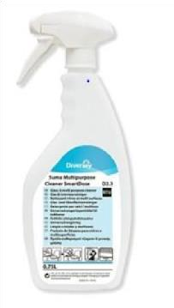

1. Pre clean soiled surfaces with Suma Multi D2.3 SmartDose solution to remove all visible dirt, food particles and debris.
2. Wipe the table/surface thoroughly using a clean cloth or disposable blue/paper roll**\***

# Stage 2 Suma Bac D10 SmartDose

1. Spray the clean surface with Suma Bac D10 SmartDose.
2. Leave the solution on for 30 seconds.
3. Wipe the table/surface thoroughly with disposable blue/paper roll and allow to air dry.

*Cloths should not be used during stage 2 of the cleaning process. If staff use cloths these must be discarded or laundered after stage 1 of the cleaning process is complete.

1. **Cleaning up spillages and waste:**

Staff should deal with blood and body fluid spillages as quickly as possible and keep children away from the spill. Staff should ensure that PPE (disposable gloves and disposable apron) are worn before the cleaning process begins. A fluid-repellent surgical facemask and eye protection should be worn if there is a risk of splashing with blood or body fluids to the face.

* Ensure appropriate PPE is worn including disposable gloves and a disposable apron.
* Prepare a solution of general-purpose neutral detergent and a solution of disinfectant (prepared according to the manufacturer’s instructions).
* Use paper towels (or kitchen roll) to soak up the spillage then place into a disposable, leak proof plastic bag.
* Apply disinfectant solution to the spillage. Wipe off any disinfectant solution left after cleaning up the spillage.
* Wipe down area with paper towels (or kitchen roll) soaked in detergent solution then wipe dry with paper towels or kitchen roll
* Remove PPE and put into the plastic bag, seal bag and place in waste bin.
* Wash hands thoroughly.

Do not use chlorine-based disinfectants e.g. household bleach directly onto spills of urine spillages (as this can release a chlorine gas). Soak up urine first with paper towels before using a disinfectant solution.

Once the cleaning process is complete staff should remove PPE and put into the plastic bag, secure and seal the bag then place it in the waste bin. Staff must ensure they wash their hands with liquid soap and running water.

When a mop is used to clean up spills from water trays etc, it should be rinsed thoroughly after every use ensuring cleaning solution and dirt are rinsed away and the mop is completely clean. Cleaning solutions used should be prepared as stated on the manufacturer’s instruction label and only approved solutions should be used. Mops should be stored away from the playroom in a cool dry place. Mop heads should be replaced regularly and when visibly dirty. Mops should only be used for a specific area i.e. playroom or toilets. Mops should be clearly labelled and placed in separate buckets which are also labelled.

Bins should have a pedal and always lined in each of the areas where waste is produced e.g. food areas, nappy changing areas.

Waste bins should have a lid, never be overfilled and bins should be emptied at the end of the day and during the day if needed. Staff should wear appropriate PPE if required when emptying and cleaning bins. Immediately afterwards PPE should be removed and hands washed with liquid soap and running water.

1. **Sharps:**

Sharp objects (‘sharps’) i.e. needles must be disposed of in an approved sharps container, made to UN3291 standards. Arrangements for collection should be put in place by contacting EAC environmental health team. The sharps container must be kept in a safe and secure place away from children and visitors at all times.

1. **Linen/Laundry:** Soiled clothing

Carefully dispose of any soiling (faeces) found on clothing / linen into the toilet e.g. from reusable nappies.

All ECC’s should have a closed container which is only used for storing soiled clothing within the nappy changing area or in a separate room away from any areas accessed by the children. Soiled clothing should be double bagged and labelled with the child’s name and the date that the clothing was soiled. Staff should not rinse soiled clothing by hand (including reusable nappies). Bags should remain in the container until returned to the child’s parent/carer at the end of the session. In order to protect the dignity of the child, staff may place the soiled clothing (as long as it is double bagged) in the child’s own bag towards the end of the session but this must only be for a short period of time and not be accessible to children. Staff handling soiled clothing at the end of the session should always wear appropriate PPE and wash their hands immediately afterwards.

Soft furnishing such as pillows and blankets not used for sleeping arrangements should be washed regularly or if visibly dirty. Any ECC items contaminated with bodily fluids, must be removed immediately and washed on its own at the highest temperature.

Staff must ensure laundry rooms are kept clean and tidy at all times. SMT should ensure clothing items are returned to parents/carers as soon as possible to minimise excess clothing being stored within cloakrooms.

1. **Sleeping arrangements:**

If children are sleeping during their time in the ECC, blankets and sheets should be washed after every use and mats wiped down using antibacterial spray. All linen must be washed at the hottest temperatures specified on the fabric and staff should ensure fresh linen is kept in a clean, dry area separate from used linen at all times.

1. **Caring for children who become unwell:**

* Staff must report immediately to the SMT if any child has the following signs or symptoms (early signs of infection):
  + Appears unwell (feels hot or looks flushed) or complains of feeling ill for example muscle aches and headaches.
  + Diarrhoea and/or vomiting
  + Blood in their faeces
  + An unexplained rash
* Contact should be made with the child’s parent/carer to inform them that their child is unwell and ask for them to be collected as soon as possible.
* Staff must ensure that children who are sick have limited contact with other children until they can be collected by their parent/carer.
* Children who become unwell during the session should be made comfortable and be cared for by a member of staff they are familiar with until they are collected by parents/carers.
* Staff should wear PPE as appropriate whilst awaiting the child to be collected.
* Staff must clean any equipment/toys/resources that have been used by a child who has a suspected infectious disease and record this on the appropriate cleaning schedule.
* If the parent/carer cannot collect their child and the person collecting is not known to the staff, a password should be agreed with the parent/carer to confirm at collection.
* All suspected infectious illnesses must be reported to a member of the SMT who will advise of any exclusion periods required to be followed.
* Management should provide regular communications and reminders to parents/carers to help reduce the spread of infection, such as
* the signs and symptoms of infection
* a reminder to stay home if feeling unwell or have a fever

People who are showing symptoms of an infectious disease or have been diagnosed by a health professional should be advised to stay away from the ECC for the minimum period recommended and until well enough. **The need for any exclusion, and the period of exclusion for Scotland is set out in the UKHSA guidance section on**[**managing specific infectious diseases: A to Z**](https://www.gov.uk/government/publications/health-protection-in-schools-and-other-childcare-facilities/managing-specific-infectious-diseases-a-to-z#food)**.**

### **Keeping animals on site and contact with animals**

The [UKHSA guidance](https://www.gov.uk/government/publications/health-protection-in-schools-and-other-childcare-facilities/preventing-and-controlling-infections#safe-management-of-the-environment) provides advice on reducing the risk of infection, where settings choose to include pets and other animals to enhance the learning environment. Anyone touching an animal or their bedding should wash their hands thoroughly after contact, in particular before eating.

Activities such as farm visits, outdoor learning and contact with animals can pose an additional risk of infection and these risks must be considered within an appropriate risk assessment (See RA 017 for more information).

The SMT should give consideration to people who may be at a greater risk of developing a severe infection.

The SMT should also refer to the following guidance:

* [Scottish Framework for Safe Practice in Off-site Visits – Going Out There](https://www.goingoutthere.co.uk/)
* [Scottish Advisory Panel for Outdoor Education](https://www.sapoe.org.uk/)
* [Access to Farms website](https://visitmyfarm.org/resources/code-of-practice)
* [Access to Farms Code of Practice: teacher’s guide](https://visitmyfarm.org/resources/code-of-practice)
* [Preventing or controlling ill health from animal contact at visitor attractions or open farms](https://www.hse.gov.uk/agriculture/topics/visitor-attractions.htm)
* [Out to Play – creating outdoor play experiences for children: practical guidance](https://www.gov.scot/publications/out-play-practical-guidance-creating-outdoor-play-experiences-children/)

1. **Outbreak of infection:**

It is important to keep an up-to-date list of the following when managing an outbreak:

* The names of those children/staff who are ill
* The symptoms, if known (for example, vomiting and diarrhoea)
* When the children/staff became ill and when first noticed or reported (if known)
* The date they last attended the childcare setting
* When the parents were contacted
* What time the child was collected
* Who was informed about the outbreak
* The advice received
* Advice given to parents/guardian

An outbreak is considered when two or more, or a higher than expected number of cases are confirmed or suspected (in the same group of people), affecting people using the service. A member of SMT will seek advice from the local Health Protection Team when an outbreak is suspected and follow advice given. A member of the SMT will notify the Care Inspectorate immediately to report the outbreak.

Whilst awaiting guidance from the HPT the SMT, should minimise any spread of infection by reducing access to shared sensory experiences, such as water play, sand play, dough etc.

NHS Ayrshire and Arran Health Protection Team

Phone: 01292 885 858

Out of hours: 01563 521133

Email: [hpteam@aapct.scot.nhs.uk](mailto:hpteam@aapct.scot.nhs.uk)

1. **Accidents and Incidents:**

If a child or adult within the setting is subject to an exposure injury or bite, the following protocol should be followed;

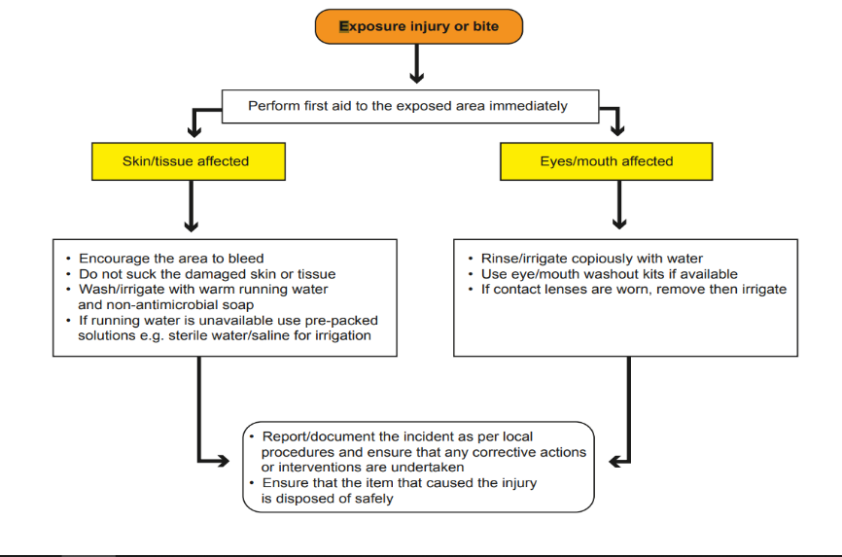

The chain of Infection

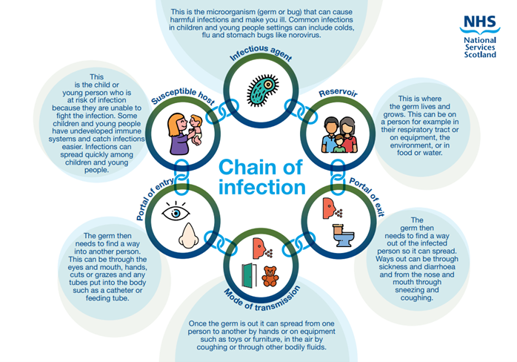

-------------------------------------------------------------------------------------------------------------

**This policy considers:**

* <http://www.washyourhandsofthem.com/children's-pack.aspx>
* Keep it clean and Healthy (copies are provided during pre registration training) [www.dettol.co.uk](http://www.dettol.co.uk)
* Disposal Gloves: use and management [www.careinspecotrate.com](http://www.careinspecotrate.com)
* Infection Prevention and Control in Childcare Settings (Daycare and childminding settings) updated 2018 [www.documents.hsp.sct.nhs.uk](http://www.documents.hsp.sct.nhs.uk)
* [Health protection in children and young people settings, including education - GOV.UK (www.gov.uk)](https://www.gov.uk/government/publications/health-protection-in-schools-and-other-childcare-facilities)
* Nappy changing facilities for early learning and childcare services: information to support improvement [nappy-changing-guidance-for-early-years-and-childcare-services.pdf (careinspectorate.com)](https://hub.careinspectorate.com/media/1558/nappy-changing-guidance-for-early-years-and-childcare-services.pdf)

**Policy created:** July 2022 **Policy last reviewed:** 18 July 2025