
June 2025 Newsletter

Dear Parents and Carers,

The previous term has flown in so quickly and we are now in our final term before the summer break. Hopefully we are beginning to see the start of some better weather ahead, allowing us to offer a wider selection of learning experiences outdoors. Please ensure your child has a full change of clothes in their bag as we continue to encourage outdoor learning activities and play for all.

Please remember to inform Julie/Eunice in the Office if you have changed address, phone number or emergency contacts. It is important we are able to contact you.



Dates for your Dairy:

- Wednesday 25th of June – Graduation Celebration for school leavers AM & PM (invitations have been issued)
- Friday 27th of June – Close for Summer Break for all Term Time children
- Wednesday 6th August – Celebration Fun Day – 80 years of Flowerbank!
- Monday 18th & Tuesday 19th August – In-Service - Centre closed to all children
- Wednesday 20th August – Start of the new term

Butterflies:
We have now released all of our butterflies, children from all playrooms have enjoyed the experiences involved in the life cycle of the butterfly and all the discussions and learning that took place.

Sponsored Sports Day Event:
Thank you to all our families who came along to our obstacle sports day event, a fun day was had by all. A huge thank you to all the families who have handed in sponsor money and forms for this event, we have raised an amazing total of £2090!! We are so grateful to all of our families for their donations, this money will support us to enhance our outdoor area and resources to deliver many outdoor experiences to the children. Once we have purchased the items for outdoors we will update you all. This money will also support our end of term celebrations.

Please look at your child’s Online Journal for a more in-depth look at what your child has been taking part in over the last term. Comments and learning from home are always greatly received.
Playroom 1 (3-5’s) Trips:
This year we will be arranging smaller group trips for the children in Playroom 1. Our children who attend term time will have their trip prior to the summer and all other trips will take pace during the summer term. Unfortunately due to the bus strikes our trips are taking place within our local community this term.
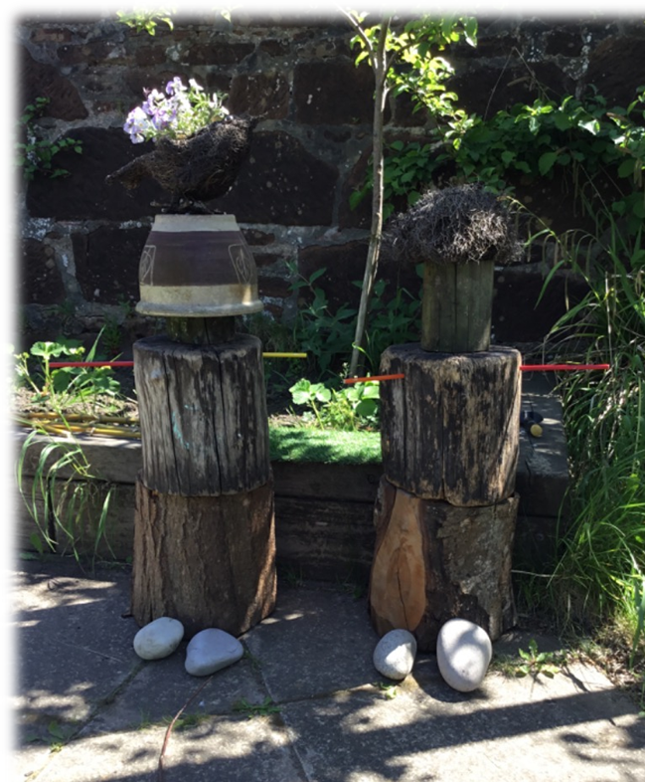
Natural Scotland Competition:
Staff and children from our Eco Committee worked really hard on an entry for the Nature Scotland competition and they designed and made 2 nature guardians for our ‘secret garden’.
We are so proud of our Nature Guardian creations and we named them Bertie and Peggy.
We won the Early Years to P3 category!

Staffing:
In the new August term we will have some staffing changes, Morag, Sharon and Amy will be moving to term time establishments and we would like to wish them all good luck and we will miss them being part of our Flowerbank team. Elle will be staying at Flowerbank on a permanent basis which we are delighted with. Alan from our office has retired and we would like to wish him all the best for his retirement and all the trips he has planned. We will update you once these vacant posts have been filled.
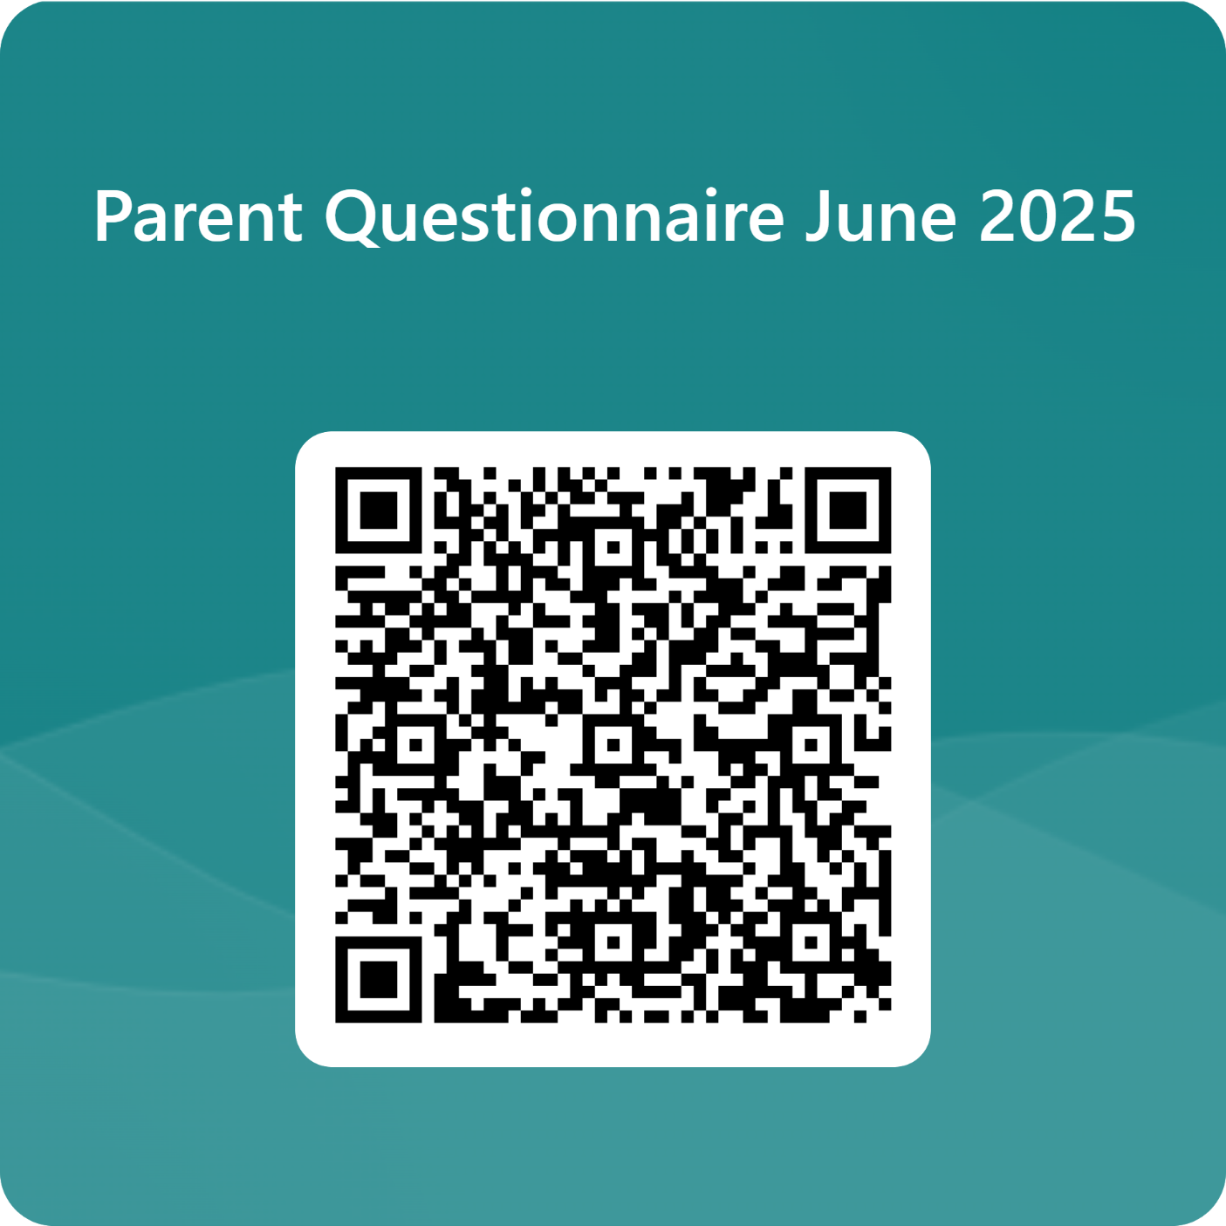
Self-Evaluation and Feedback:
We are at that time of the year where we are evaluating our Improvement progress and setting new priorities for 25-26 academic year and we are asking for your assistance to do this. We would be grateful if you could fill out the questionnaire which was emailed or via the QR code.

80 Years of Flowerbank!
We are having a celebration day on Wednesday 6th August to commemorate 80 years of Flowerbank and we would like to invite all families along to join in with our celebrations. We would be grateful if anyone can support us with the planning of this event and any home baking would also be appreciated. Times to be confirmed.

Parents Committee:
I would like to take this opportunity to thank our Parents committee members for giving up their time to attend the meetings and support with events throughout the centre.

Thank you to all parents and carers for your continued support, we would like to wish you all a lovely summer break when the time comes.
To everyone leaving to start their new adventure in Primary 1, good luck - we know you will all be amazing.
☺

From Margaret and all the Staff at Flowerbank ECC

