
August 2024 Newsletter
Dear all,

A great big welcome back to those children returning to us after their summer break, and a very warm welcome to all our new children and their families.

We have completed our Improvement Plan for 2024-2025 and our Standards and Quality Report for 2023-2024. A copy of these will be available to view in the reception area, however if you would like a copy please speak to a member of management/clerical who will arrange for a copy to be emailed to you.

Our focus for improvement this year is:

- Increase leadership opportunities for staff and children across all areas of the ECC.
- To provide high quality learning through consistent pedagogical approaches across all areas of the curriculum to meet the needs of all learners.
- Provide high quality individualised early intervention that supports all children with an identified support need and/or speech, language and communication need to reach their full potential within a nurturing and calm environment with highly trained staff.
- To increase partnerships with parents to ensure outcomes are improved for all learners.



In-Service Days – 19th and 20th of August (centre closed to all)
September Weekend - 20th and 23rd of September (centre closed to all)
October week - 14th-18th of October – closed to term time children
October In-Service- Monday 21st of October (centre closed to all)
Christmas Break - close on 20th December for all term time children and return on Monday6th of January 2025

This year we will celebrate our 10th Anniversary of moving into this building and we will be planning a celebration event. Date – TBC

A copy of the holiday arrangements for our children who attend on a term time basis can be requested from our main reception.

Staff News:

We would like to welcome Kristeen and Elle to our team and they will be based in our 3-5 room. We have a few changes to staffing this year and would like to wish Stephen good luck as he takes up a new position closer to home. Kirsty and Louise will be moving through to Playroom 2. Rebecca finished up for maternity leave at the end of June and we would like to congratulate her on the birth of her new baby boy Finn.
Parents Committee:

We are currently looking for volunteers to join our parents committee and we need a minimum of 4 members to run this group. If any parents are interested or would like to find out more about this please see myself (Head of Centre) or Carol (Depute Manager).

Self-Evaluation and Feedback

We are re-introducing a “Question of the Month” Floorbook to our entrance and would love to hear your views. Each month we will add a question and we are asking if parents/carers can add their comments on a post it to add to the book. The Question of the month for August/September is “How welcoming do you find our Centre?” Thank you in advance for your support.



 Eco Update

We have been focusing on recycling and ways to become more Eco friendly and we are always looking for views from parents. Please add any comments to our Eco board in our hall area or speak to one of our Eco Champions. We are also proud to announce that we have obtained our Green Flag Award and also a bronze award in East Ayrshire Clean Green Awards.

Car Parking

Can I please ask parents/carers to follow the 5mph restrictions within the car park to ensure the safety of all users and visitors to the Centre. We understand the car park can become very busy however, can parents please ensure the Disabled space is kept free for Blue Badge holders only. Can I also ask parents/carers not to park in front of the Sir Alexander Fleming building as that area is their drop off/pick up zone for their buses and requires to be clear as the buses arrive regularly throughout the day.

Can you help?

We are running low on paper tissues and baby wipes, if you are able to donate any of these items it would be very much appreciated.

Parents Group

Our Parents group for our under 3 age group is very well attended and create a great opportunity for parents/carers and children to take part in very valuable learning experiences. If you would like any more information on this group or have a child in that age range and would like to come along please speak to Charne or one of the staff in Playroom 2 or 3.

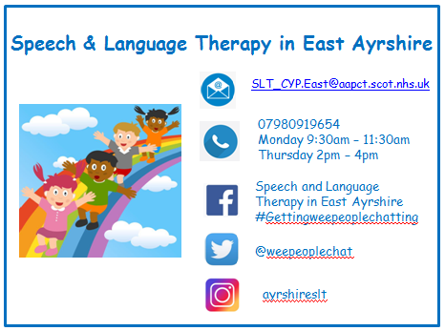

Allotment:


We are looking for parent helpers to accompany us on our Allotment visits to support us in maintaining the area and planting/growing our crops. If anyone can help or is interested in finding out more about this please come and speak to a member of staff.

From Margaret and all the Staff at Flowerbank



