Climate change manifesto
Fenwick primary school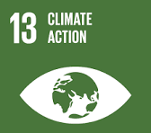
What we want to do | .recycle
.walk more | .reuse
.reduce food waste | .save energy
.reuse paper and cardboad  .turn off lights  .recycle paper plasic metal glass | .reduce  .turn off taps

