Say No to Racism
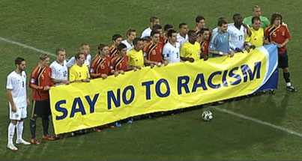
We are all human Beings! No matter what skin color we have.

