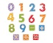  Numeracy |   Literacy | 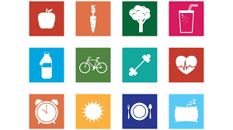  HWB |   Other
Education City  Try playing some numeracy games and activities from the “Classwork Folder”.  P4s “First News” - log in and read about what is happening in the news. | Education City  Try some literacy activities from the “Classwork Folder” | P.E  Take part in Joe Wicks morning workouts. | BSL British Sign Language activity  Can you learn the alphabet in BSL or sign a song. Watch the clips on the blog or print the hand signs out .
Measure  White Rose Maths  Revision of measuring in metres, centimetres and millimetres. Try out some worksheet activities or watch the power point and answer orally. | Talk for Writing Activity  This week you have a story with lots of tasks to go with it. This task is for this week and for last week. There are worksheets and activities to print. | PATHs – SEL activities  Pictionary activity + Challenge Activity  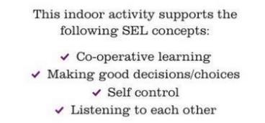 | Digital Technologies  Update your own  e-portfolio.  Or try BBC Dancemat to increase your typing speed.
Sumdog  You will find your new password for Sumdog and username in your email.  Try out our class competition. | Spelling  See attachment for your spelling lists for this week.  Use the BSL sign language activity to have a go at signing some of your spelling words | Mindfulness  Try some mindful breathing activities. | Article 15 Right to Association Whole School Task (2 week task)  Schools Value Task see attachment on our Class Blog
LOST – Outdoor Shapes  Last week we were revising our knowledge of shape. You can have fun making some of those shapes with materials from outside. See our blog link for ideas. | Reading Comprehension  Complete some Giglets activities or print some comprehension worksheets from below. | BBC Bitesize – Communicating with Sign Language. Watch the clip on our blog.  Think about how Shaun is the same as other boys his age, as well as what makes him different. What could the other pupils do to help to make Shaun feel less different and left out? | RRSA  We are a Rights Respecting School and it is important that we continue to learn about the UNCRC. See the activities based on the Article of the Week on our blog.

