**Purple Spelling Homework**

This week we are learning the **<ae>** phoneme.

Try your best to practise the words below by completing some of the suggested activities. You do not need to complete all activities nor do you need to practise all words, maybe just focus on the words you find a bit trickier. I suggest one activity per night.

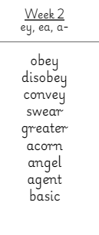

Spelling Menu

|  |  |  |  |
| --- | --- | --- | --- |
| **Active Spelling**  Spell out your words while you…  **Clap** for vowels  **Click** for consonants | **Creative spelling**  Cut letters from an old newspaper or magazine (with permission) and stick them down to make your spelling words. | **Vowels and Consonants**  Write your spelling words using 2 colours: one colour for vowels (a, e, i, o. u) and another colour for consonants. | **Act your words**  Try saying your words in a different accent like an actor from a movie. |