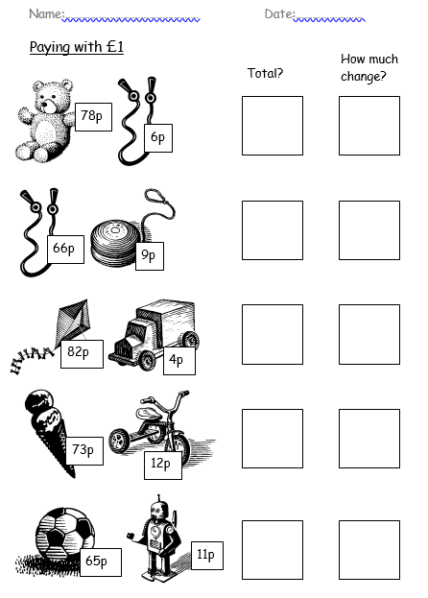
Please complete the following questions using column subtraction.

This is a challenging homework linking our skills of column addition
and column subtraction together to problem solve to find the answer.

Step 1- Find the total cost of the objects
Question 1 in the worksheet
78p
+ 6p
84p
1

Step 2- convert pence to pounds
£1 = 100p or 84p = £0.84

Step 3- Find the change by subtracting the cost (step 1 answer) from £1
100p £1.00
- 84p 0r - £0.84

