

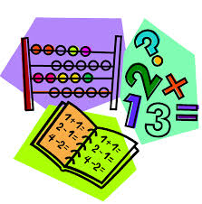

This term we will be focusing on Number (including fractions), Estimating and Rounding, Data Handling and Money.

**Number** – we will investigate addition and subtraction and the ordering of numbers to 50.

**Estimation and Rounding** – estimating and comparing using less than, longer than, more than and the same.

**Data Handling** – interpreting a range of graphs and charts.

**Money** – recognising coins and using coins to pay for simple real life items-=

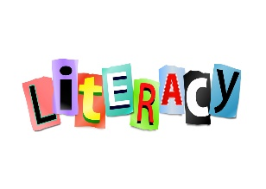

We will be working on sentence structure this term and using a range of words to make our sentences exciting. We will continue to learn new phonemes, including joined phonemes each week as well as a range of tricky and common words – to aid our spelling and reading.

Reading will be issued once weekly on Bug Club, this book will also be used in class for reading and for reading activities.

Listening and talking activities are the focus each morning during soft start.

Our class topics (see below) will be incorporated into our Literacy lessons each week – through report writing, leaflets and other ways of presenting information.





Mrs Conetta will be in class on a Monday covering NCCT, she is looking forward to teaching Numeracy, P.E. and Health and Wellbeing this term.

P.E days – Monday and Thursday.

Outdoor – Wednesday (garden) and Thursday.

We will update our **class blog** regularly so **please have a look** to see what we have been up to and for any class news / timetable changes!

# Macintosh HD:Users:judithross:Desktop:paired reading.jpgA

Our topics this term will be

**Science** – The Forces – magnetism, gravity, air resistance, push/pull and friction. Where we will explore each force and carry out experiments.

**IDL** – The World Around Us – including the Desert, the Ocean, the Jungle and Space.

**Homework**

Homework will be uploaded weekly on the Class Blog. Pupils will complete work at home and will **not** be required to provide evidence of completion.

**Rights Respecting Schools**

As we aim to earn our GOLD award we will be focusing on our school, playground and class charters. We will look at a Right of the Week each week in class.



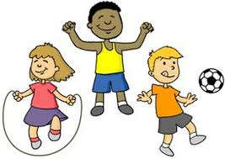

Our Health and Wellbeing lessons will centre around the PAThS (Promoting Alternative Thinking Strategies) Programme.

We will be looking at and preparing a range of healthy foods and understanding the importance of hygeine.

As we will be taking our learning outside please ensure your child has appropriate outdoor clothing for outdoor learning. These can be kept in class if easier – please make sure they are clearly labelled.

