

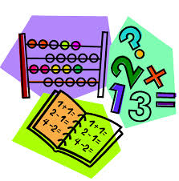

This term we will be focusing on Number, Symmetry, Time and Money.

**Number** – we will investigate addition and subtraction and the ordering of larger numbers.

**Symmetry** – understanding lines of symmetry and being able to complete symmetrical patterns and pictures.

**Time** – understanding analogue and digital clocks and reading o’clock and half past times.

**Money** – recognising coins and using coins to pay for simple real life items.

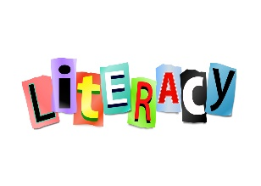

We will be working on sentence structure this term and using a range of words to make our sentences exciting. We will continue to learn new phonemes each week as well as a range of tricky and common words – to aid our spelling and reading.

Reading will be issued once weekly on Bug Club, this book will also be used in class for reading and reading activities.

Listening and talking activities are the focus each morning during soft start.

Our topic Fairyland will focus on fairy tales, imaginative writing, drama and art.

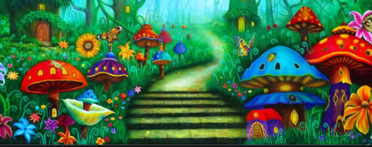



Mrs Conetta will be in class on a Monday covering NCCT, she is looking forward to teaching Numeracy, P.E. and Health and Wellbeing this term.

P.E days – Monday and Thursday.

Outdoor – Wednesday (garden) and Thursday.

We will update our **class blog** regularly so **please have a look** to see what we have been up to and for any class news / timetable changes!

# Macintosh HD:Users:judithross:Desktop:french.pngMacintosh HD:Users:judithross:Desktop:paired reading.jpgA

**Rights Respecting Schools**

As we aim to earn our GOLD award we will be focusing on our school, playground and class charters. We will look at a Right of the Week each week in class.



**Homework**

Homework will be uploaded weekly on the Class Blog. Pupils will complete work at home and will **not** be required to provide evidence of completion. Homework is reinforcement of a sample of what is being taught each week in class.

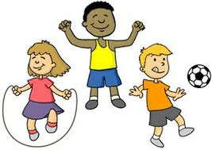

Our Health and Wellbeing lessons will centre around the PAThS (Promoting Alternative Thinking Strategies) Programme.

We will also study the human body and how to keep our bodies and minds healthy.

As we will be taking our learning outside please ensure your child has appropriate outdoor clothing for outdoor learning. These can be kept in class if easier – please make sure they are clearly labelled.

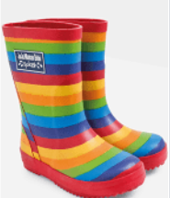

**French**

We will have the opportunity to practice our French vocabulary and learn simple phrases.

Our topics this term will be a Scottish topic, centring around Fenwick. A science Topic on the Forces and Fairyland – an imaginative Literacy topic.