

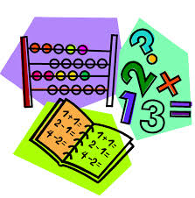

We will learn simple addition and subtraction patterns within 20. We will learn through play and the use of Number Lines, Rekenreks, Base 10 and Ten Frames.

 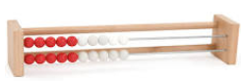

 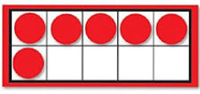

We will look at different forms of Information Handling, such as Venn Diagrams, Carroll Diagrams, simple graphs and charts. Fractions will also be investigated, namely halves and quarters. 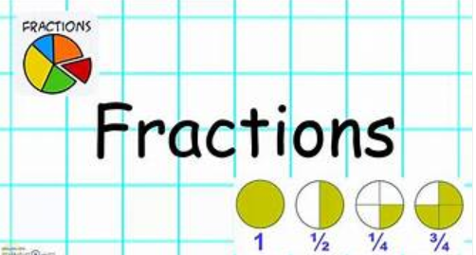 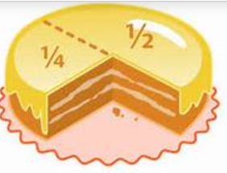

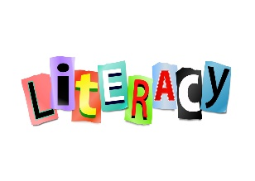

As we are beginning to find confidence in our phonemes we are now blending these to make CVC words, i.e. cat, dog, van. We will be looking at the importance of sentence structure and producing simple sentences, while learning 2 new phonemes each week.

Our Literacy Topic/Outdoor Literacy Topic will continue to centre around “The Woo in the Wild Woods” by Ayrshire author Greta York.

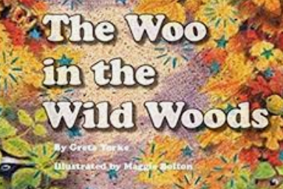

Reading will be issued once weekly on Bug Club, this book will also be used in class for reading and reading activities.



Mrs Conetta will be in class on a Monday covering NCCT, she is looking forward to teaching Numeracy, P.E. and Health and Wellbeing this term.

P.E days – Monday and Thursday.

Outdoor – Tuesday, Wednesday and Thursday.

We will update our **class blog** regularly so **please have a look** to see what we have been up to and for any class news / timetable changes!

# Macintosh HD:Users:judithross:Desktop:french.pngMacintosh HD:Users:judithross:Desktop:paired reading.jpgA

**Rights Respecting Schools**

As we aim to earn our GOLD award we will be focusing on our school, playground and class charters. We will look at a Right of the Week each week in class.



**Homework**

Homework will be uploaded weekly on the Class Blog. Pupils will complete work at home and will **not** be required to provide evidence of completion. Homework is reinforcement of a sample of what is being taught each week in class.

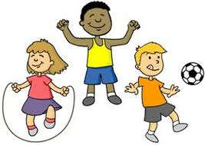

Our Health and Wellbeing lessons will cente around the PAThS (Promoting Alternative Thinking Strategies) Programme. This term we will begin the Massage in Schools Programme as a method of Mindfulness. Toothbrushing will also start later this term. 

As we will be taking our learning outside please ensure your child has appropriate outdoor clothing for outdoor learning. These can be kept in class if easier – please make sure they are clearly labelled.

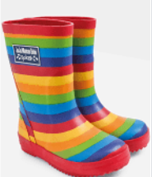

**French**

We will have the opportunity to practice our French vocabulary and learn simple phrases.

**Topic**

Our topic this term will look at Our Senses – sight, smell, hearing, taste and touch and will link with “The Woo in the Wild Woods”.